Summarised news of 2012. (Part 1)

Trình Làng tổng kết tin tức đó đây năm 2012 (Phần I)

Mời xem tổng kết tin tức
đó đây năm 2012 ( Phần I ) .
Thân ái .
Thuận Nguyễn .

2012 summary . Part I .
Today, the first part of the hot events of the past year. It includes the first four months of 2012, and the images have been selected from the resources and AFP Getty Images.
Not all of the selected images I relate to crucial events. Among those sure to choose the name Una Kim Dzng the Supreme Leader of North Korea, Vladimir Putin's victory in the presidential election, the ongoing crisis in Greece, civil war in Syria, the process of Anders Breivik, the sinking cruise liner Costa Concordia.
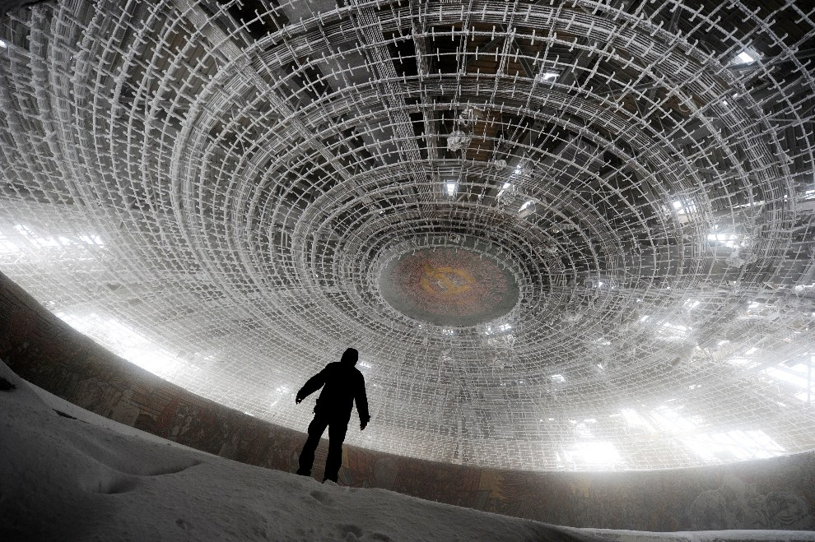
First BULGARIA, Buzłudża, March 14, 2012: The interior of the building-monument erected by the Communists at the top Buzłudży. AFP PHOTO / DIMITAR DILKOFF
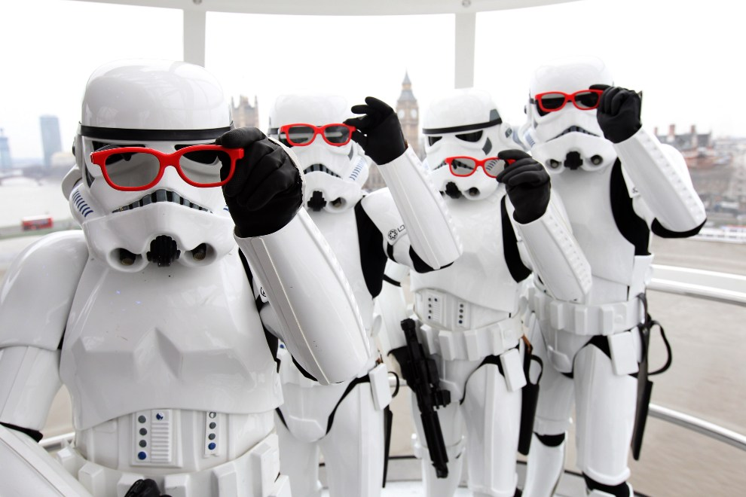
Second UNITED KINGDOM, London, February 8, 2012: Session before "Star Wars: Episode 1 - The Phantom Menace 3D 'at the London Eye. (Photo: Dave J Hogan / Getty Images)
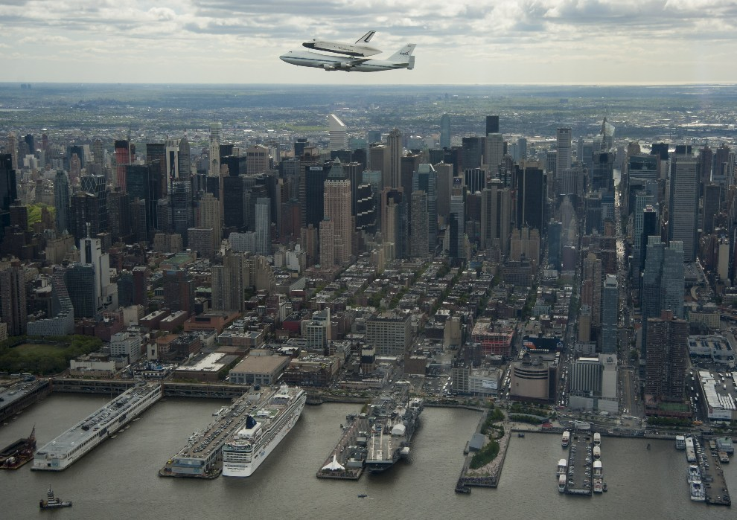
3rd USA, New York, April 27, 2012: Ferry Enterprise transported on the back of 747 Shuttle Carrier Aircraft (SCA). AFP PHOTO / NASA / Robert Markowitz
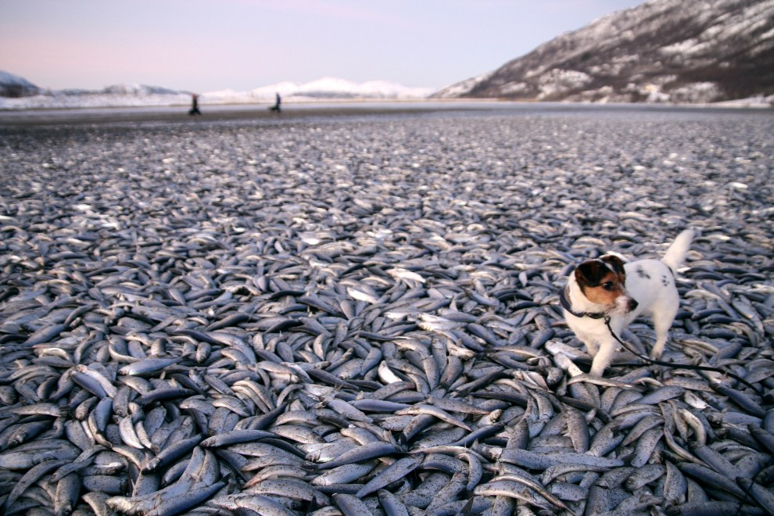
4th NORWAY, Kvaenes, Jan. 2, 2012: Female Molly wading among tons of dead herring on a beach in Kvaenes. AFP PHOTO: Jan Petter Jorgensen / Scanpix / Norway
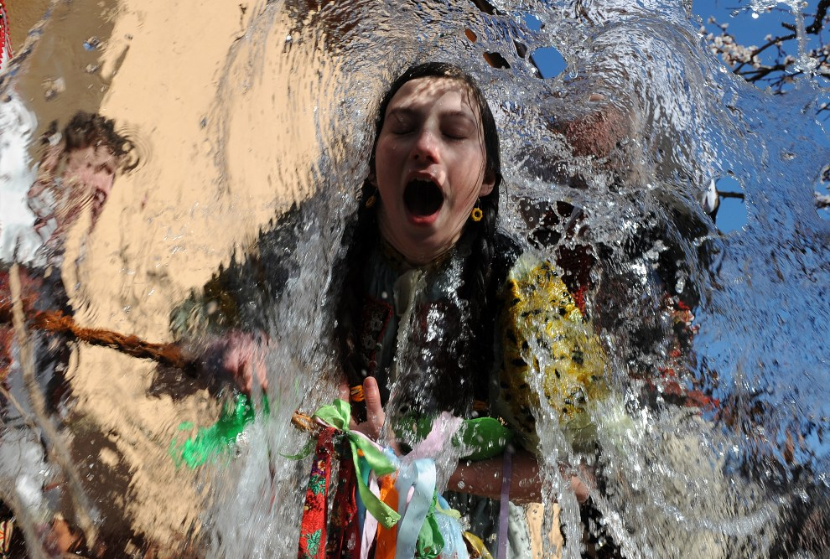
5th SLOVAKIA, Trenčianske Tepla, April 9, 2012: A young girl dipped water during Easter. AFP PHOTO / SAMUEL Kuban
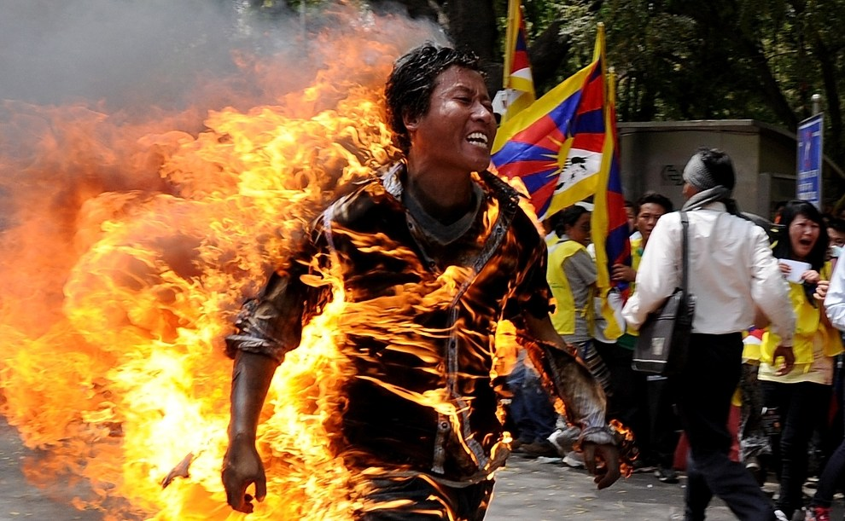
6th INDIA, New Delhi, March 26, 2012: Jamphel Yeshi who set himself on fire as a sign of protest against the visit in New Delhi, Chinese President Hu Jintao.AFP PHOTO / STM
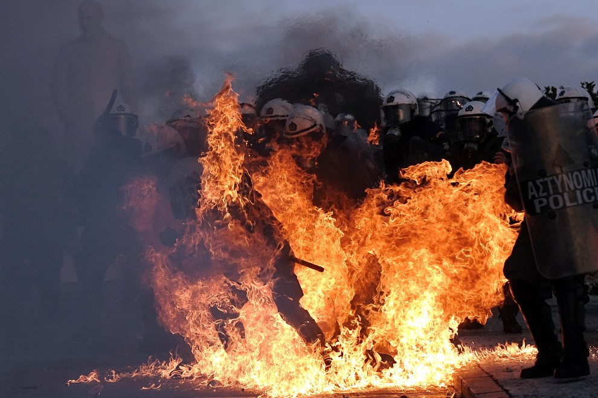
7th GREECE, Athens, February 12, 2012: Burning policeman during riots in Athens. AFP PHOTO / ARIS Messinis
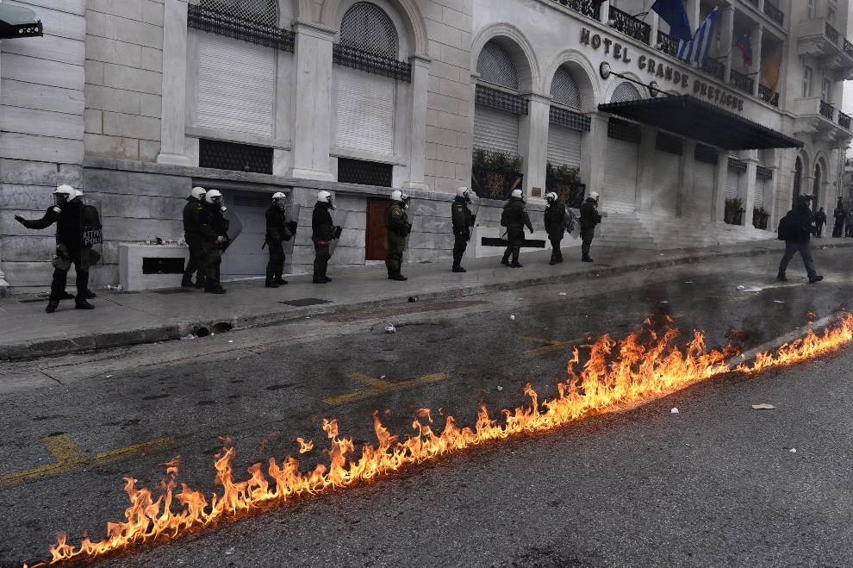
8th GREECE, Athens, February 10, 2012: Policemen guarding the order in Athens during a 48-hour general strike. AFP PHOTO / ARIS Messinis
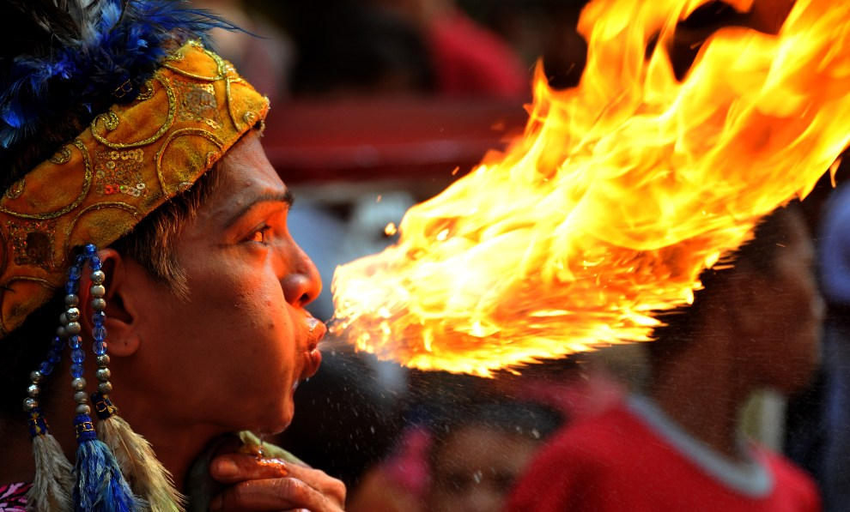
9th PHILIPPINES, Manila, January 22, 2012: A man in New Year's fire-breathing fun. AFP PHOTO / NOEL CELIS
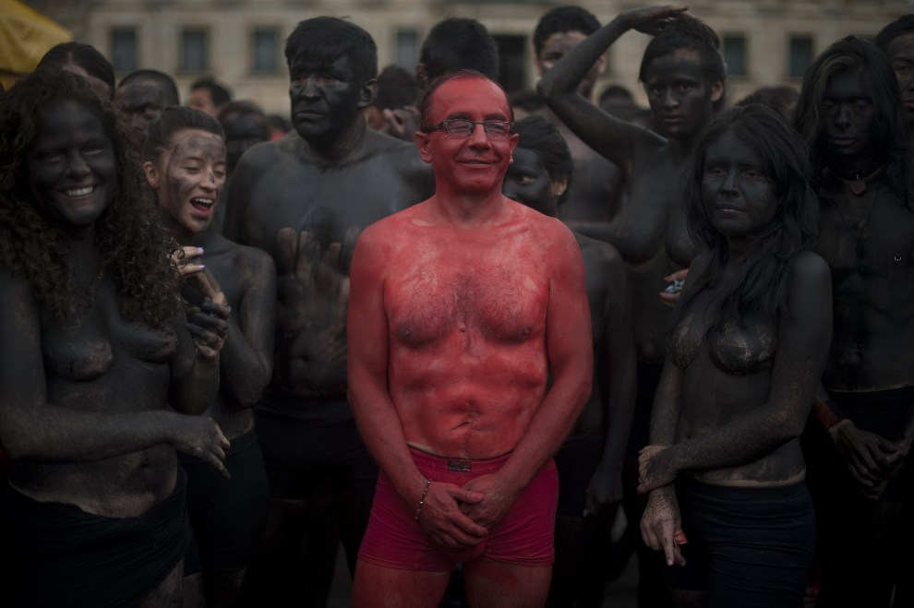
10th COLOMBIA, Bogotá, February 9, 2012: Activists protesting against bullfighting organization. AFP PHOTO / Eitan Abramovich
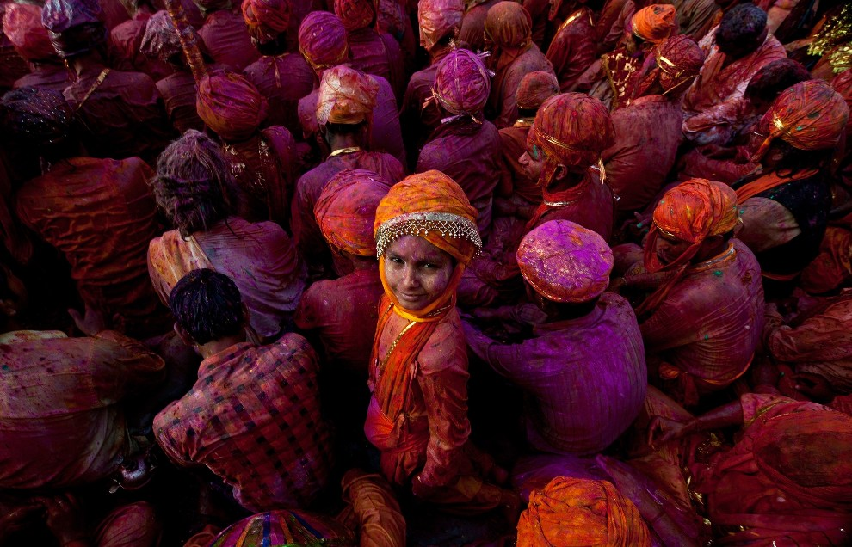
11th INDIA, Nandgaon, March 3, 2012: A child participating in the celebration of Holi holidays. AFP PHOTO / Manan Vatsyayana
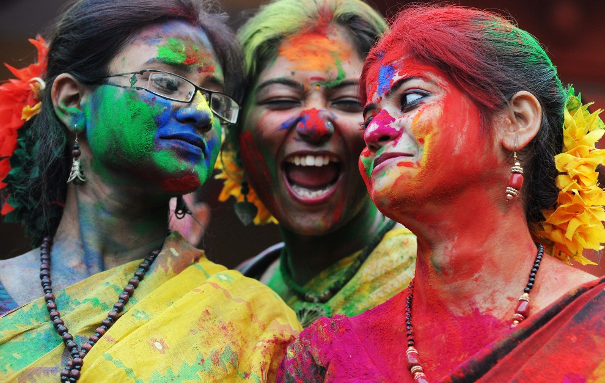
12th INDIA, Calcutta, March 6, 2012: Students playing during the festival of Holi. AFP PHOTO / Dibyangshu SARKAR
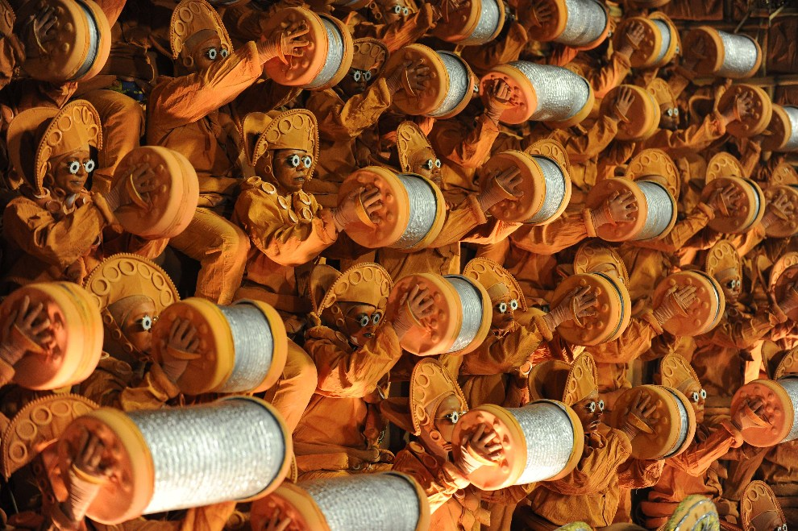
13th BRAZIL, Rio de Janeiro, February 21 2012Tancerze school Unidos da Tijuca samba during the show on Sambodromie. AFP PHOTO / Vanderlei Almeida
14th BRAZIL, Sao Paulo, February 18, 2012: A dancer from school Rosas de Ouro during the show. AFP PHOTO / Yasuyoshi Chiba
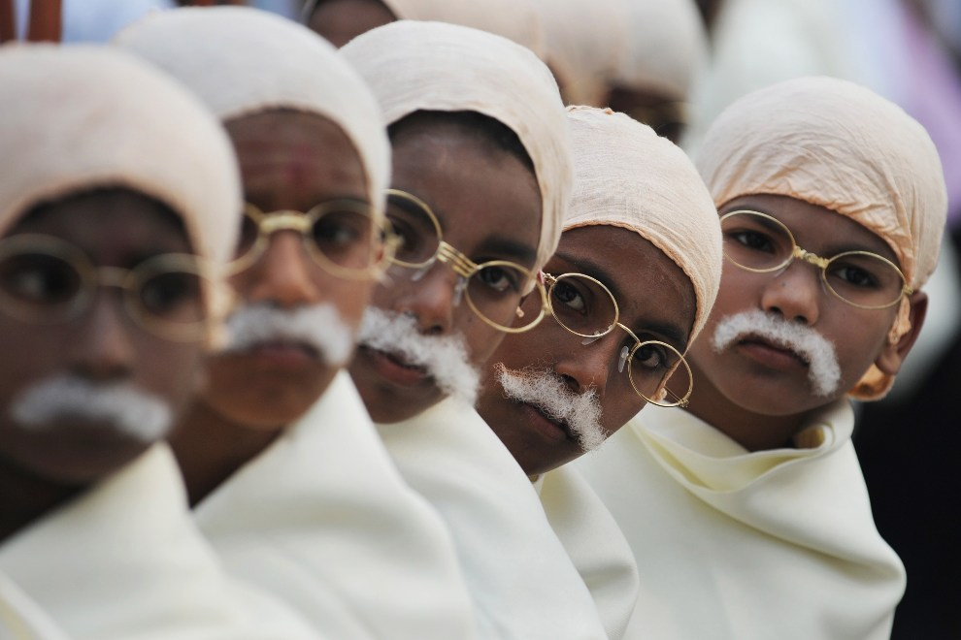
15th INDIA, Calcutta, Jan. 29, 2012: Children in costumes commemorating Mahatma Gandhi. AFP PHOTO / Dibyangshu SARKAR
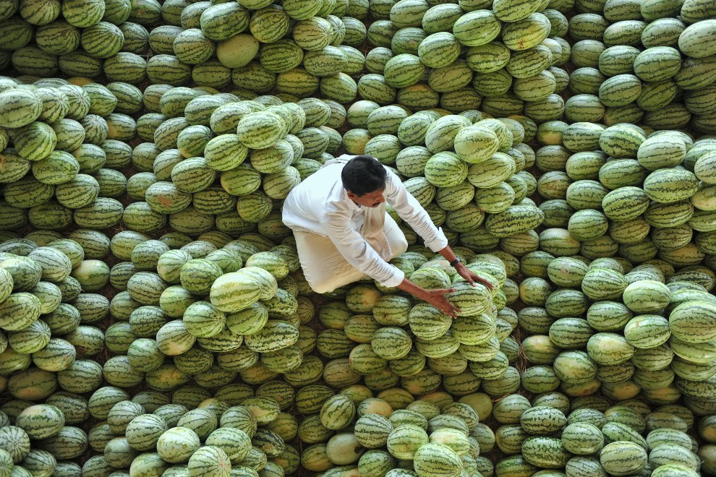
16th INDIA, Hyderabad, March 20, 2012: Lakshmi Narasaiah arranges his wares at a market stall. AFP PHOTO / Noah Seel
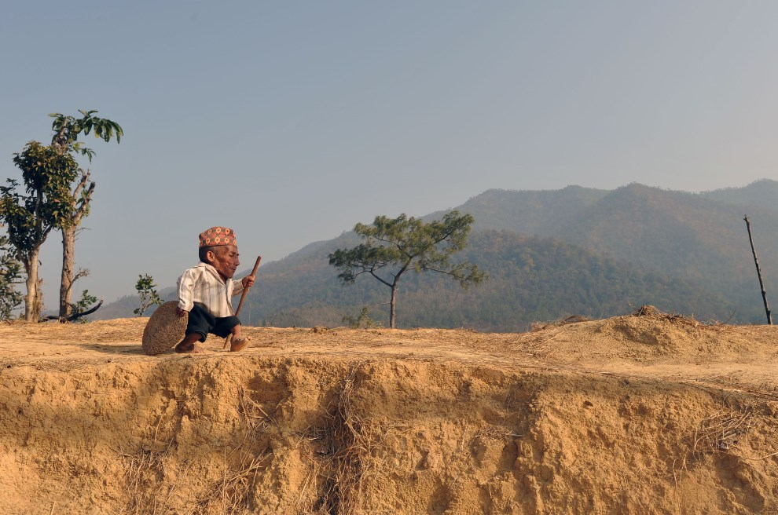
17th NEPAL, Dang, 21 February 2012: 72-year-old Chandra Bahadur Dangi, the lowest (56 cm) living man. AFP PHOTO / Prakash MATHEMA
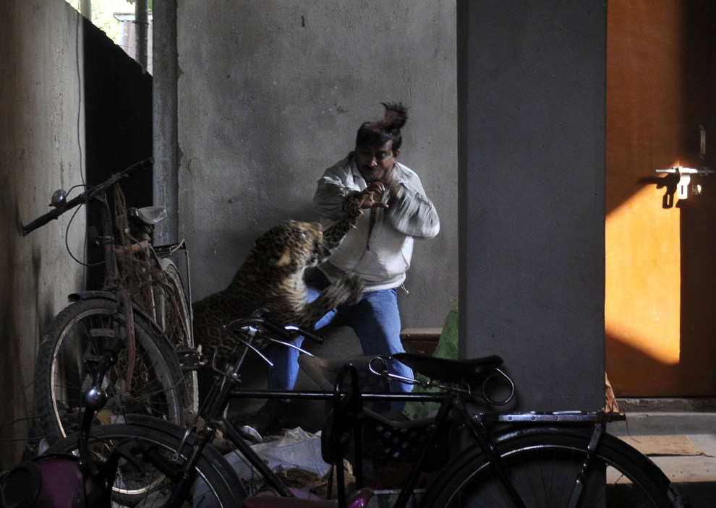
18th INDIA, Guwahati, Jan. 7, 2012: The leopard attacking one of the residents Silphukhuri. AFP PHOTO / STR
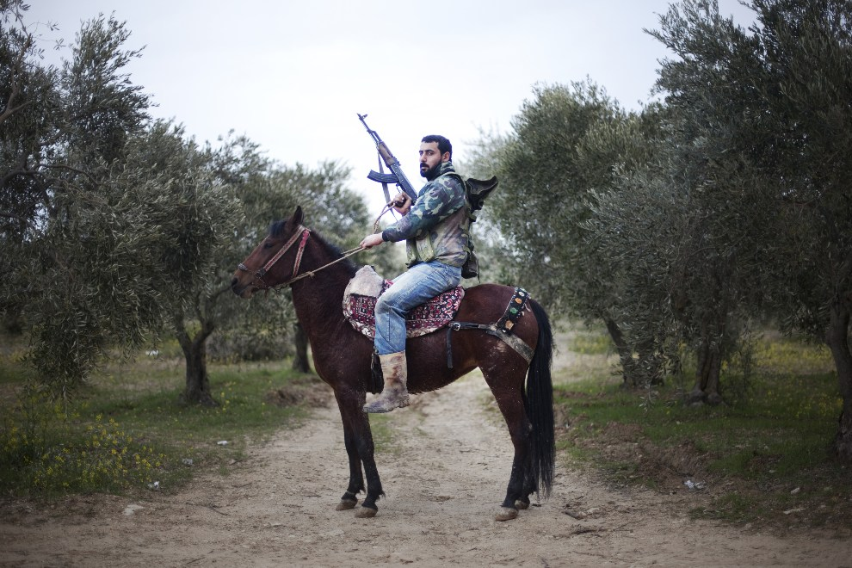
19th SYRIA Al-Shatouria, March 16, 2012: HATOURIA: rebel with the Free Syrian Army riding a horse. AFP PHOTO / GIOGOS MOUTAFIS
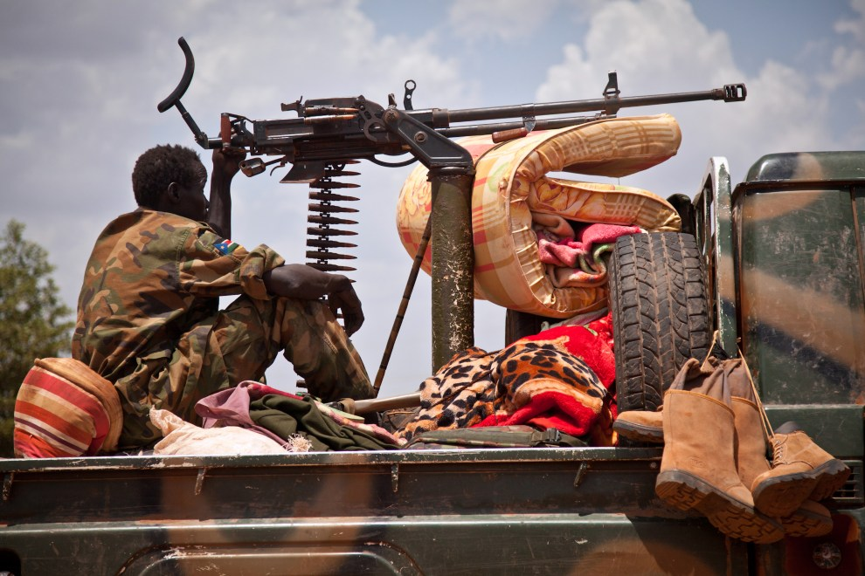
20th SOUTH SUDAN, Heglig, April 17, 2012: Soldier SPLA forces (eng. South Sudan People's Liberation Army) on the outskirts of Heglig. AFP PHOTO / Adriano O'HANESIAN
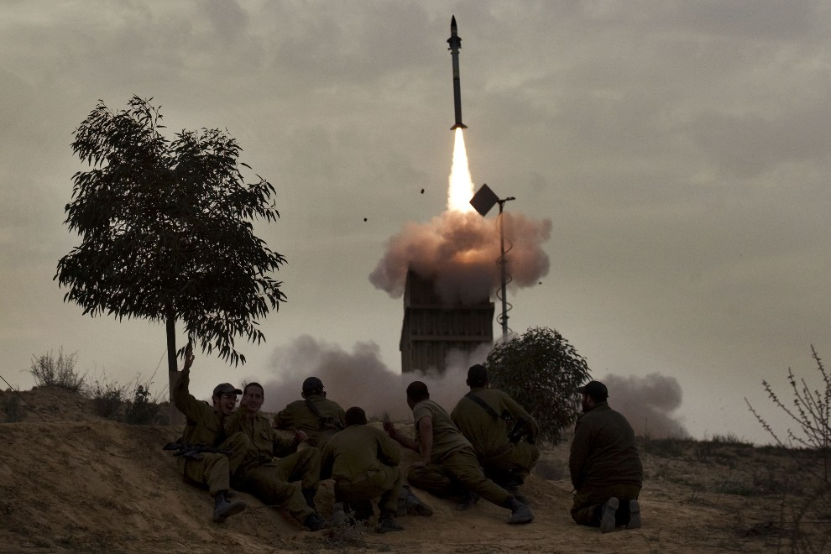
21st ISRAEL, Beer-Sheba, March 12, 2012: Israeli soldiers look at missile launchers odpalanym of Iron Dome. AFP PHOTO / Menahem Kahana
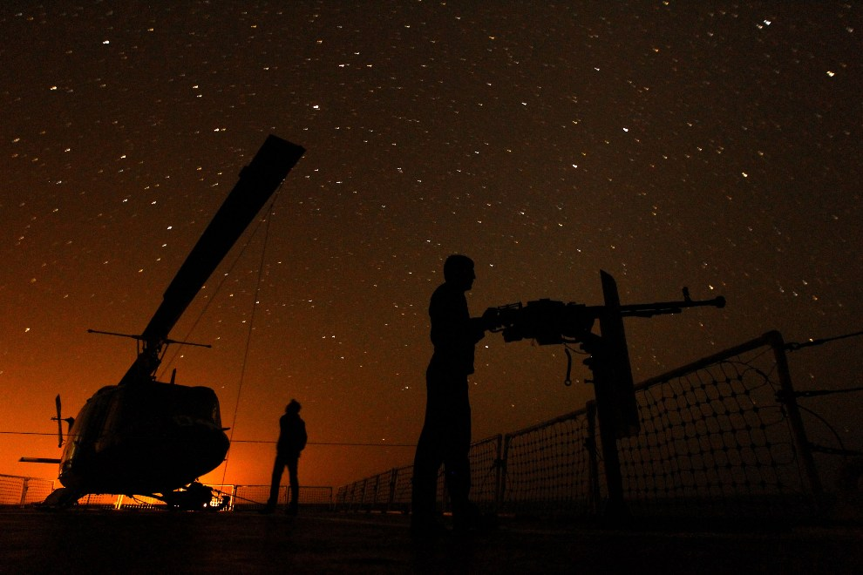
22nd Strait of Hormuz, January 1, 2012: Iranian navy maneuvers in the Strait of Hormuz. AFP PHOTO / JAMEJAMONLINE / Ebrahim NOROOZI
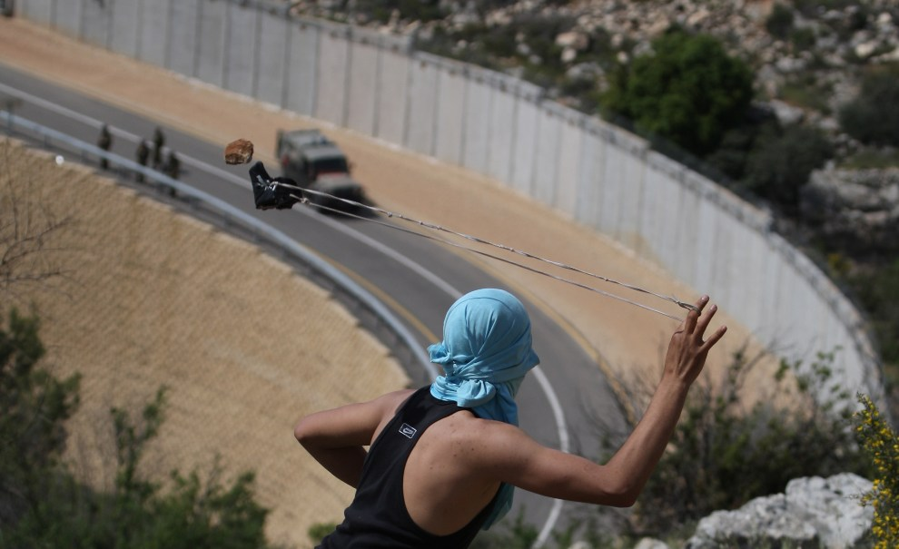
23rd WEST BANK, April 13, 2012: Palestinian with a slingshot at Israeli soldiers excellent. AFP PHOTO / ABBAS MOMANI
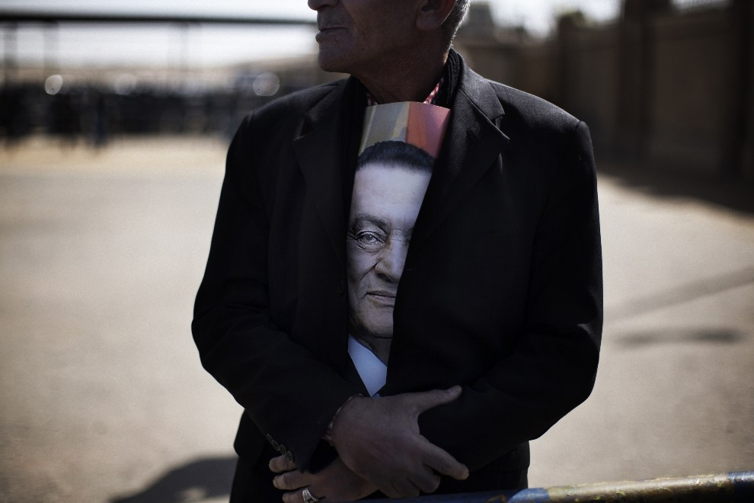
24th EGYPT, Cairo, February 22, 2012: A supporter of ousted President Hosni Mubarak. AFP PHOTO / MARCO LONGARI
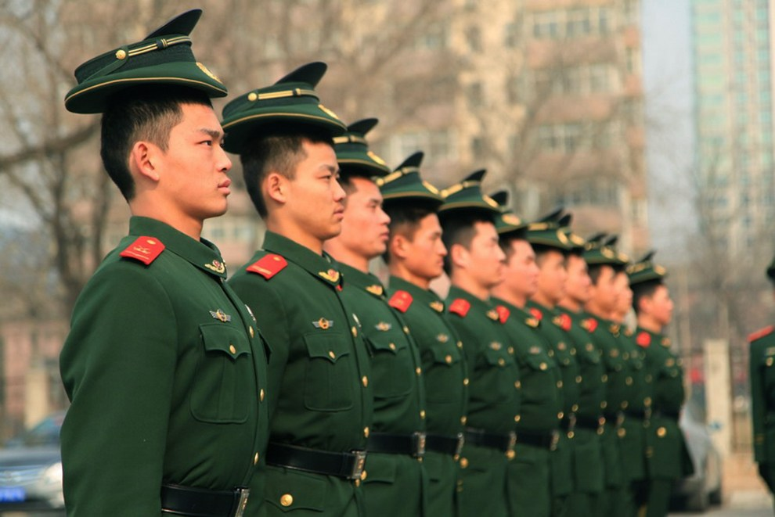
25th CHINA, Beijing, February 28, 2012: Police officers during a drill before the upcoming congress NPC (National People's Congress). AFP PHOTO
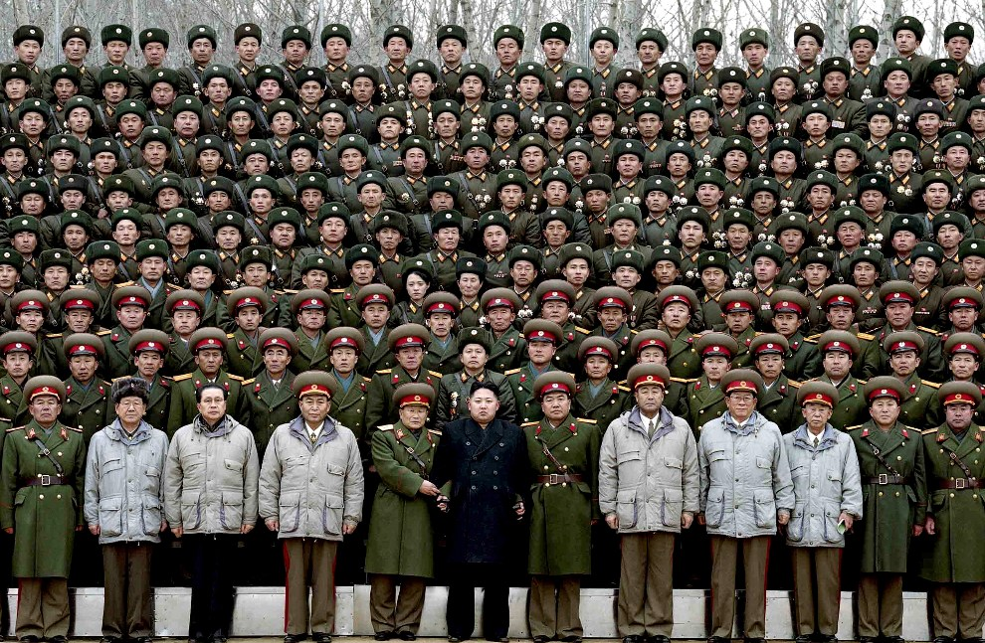
26th NORTH KOREA, January 1, 2012: Kim Dzng Un poses for photos with soldiers of the armored division. AFP PHOTO / KCNA
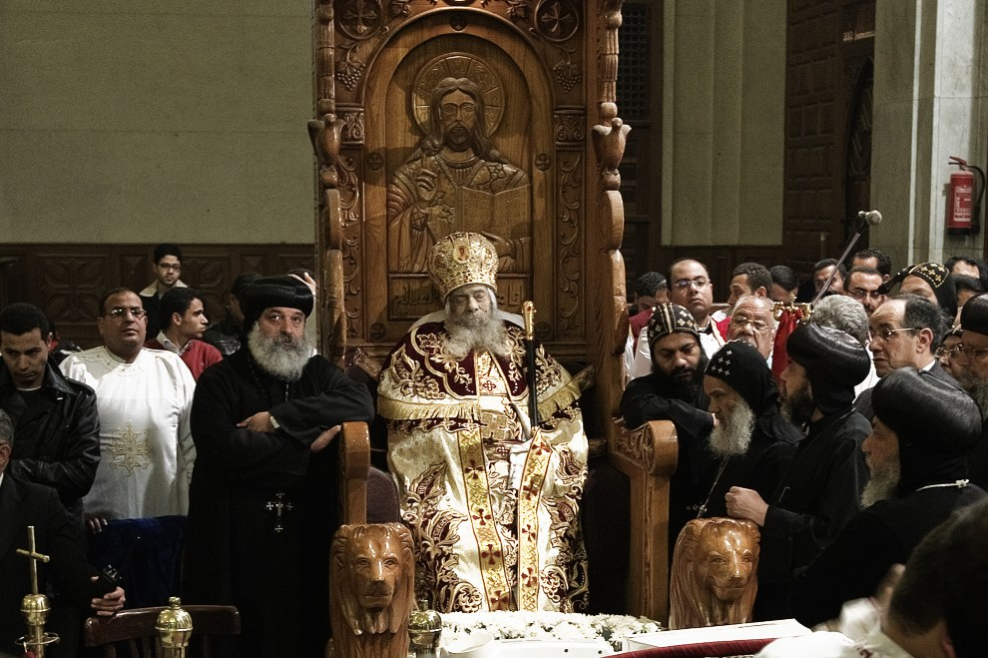
27th EGYPT, Cairo, March 19, 2012: Coptic priests gathered around the body of the late Pope Szenudy III. AFP PHOTO / Gianluigi GUERCIA
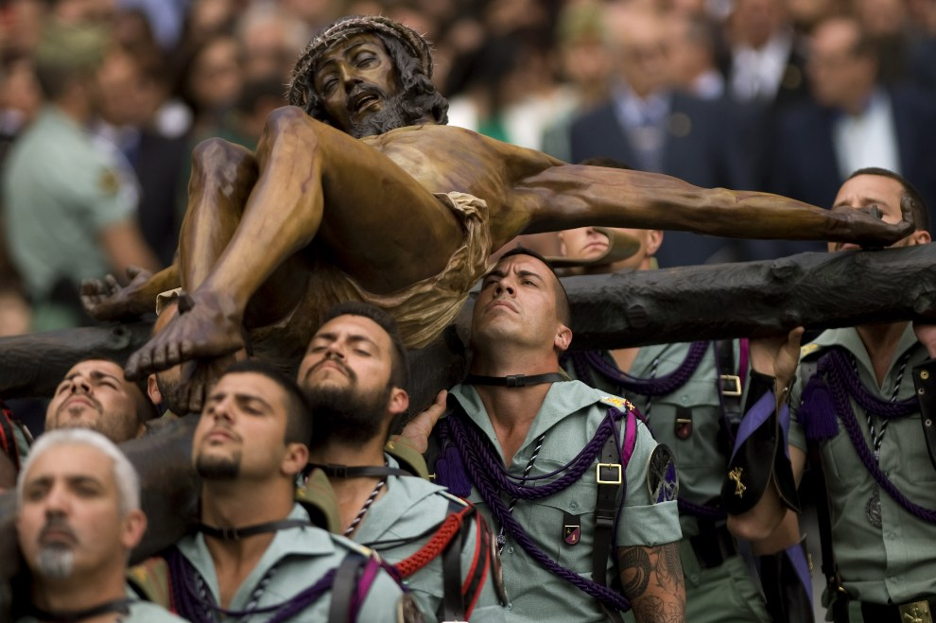
28th SPAIN, Malaga, April 5, 2012: Spanish Foreign Legion soldiers carry the cross during the celebration of Holy Week. AFP PHOTO / JORGE GUERRERO
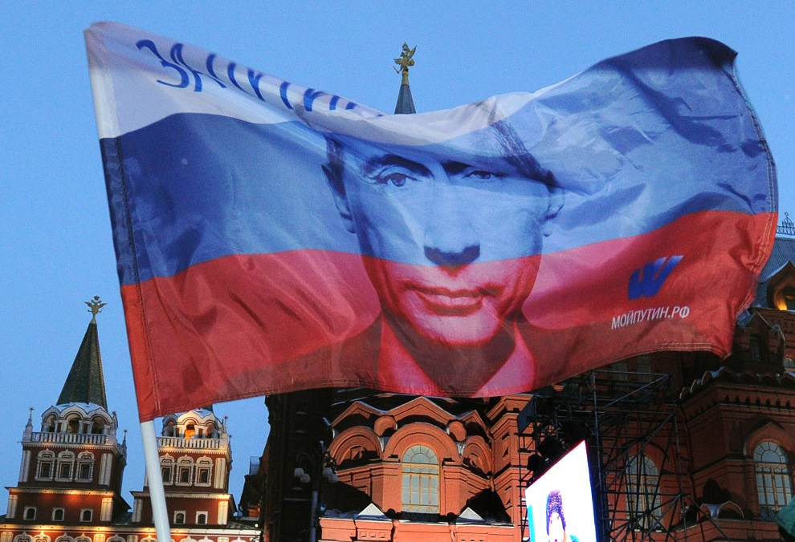
29th Russia, Moscow, March 5, 2012: The Russian flag with the image of Vladimir Putin waving the Maneżowym Square. AFP PHOTO / ALEXANDER NEMENOV
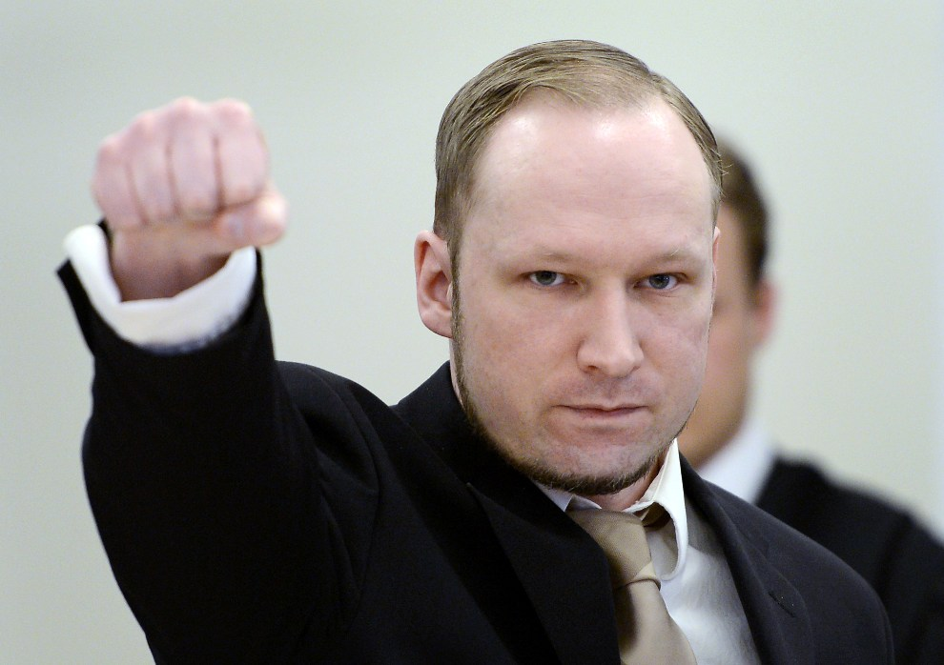
30th NORWAY, Oslo, April 17, 2012: Anders Behring Breivik in the courtroom. AFP PHOTO / ODD ANDERSEN
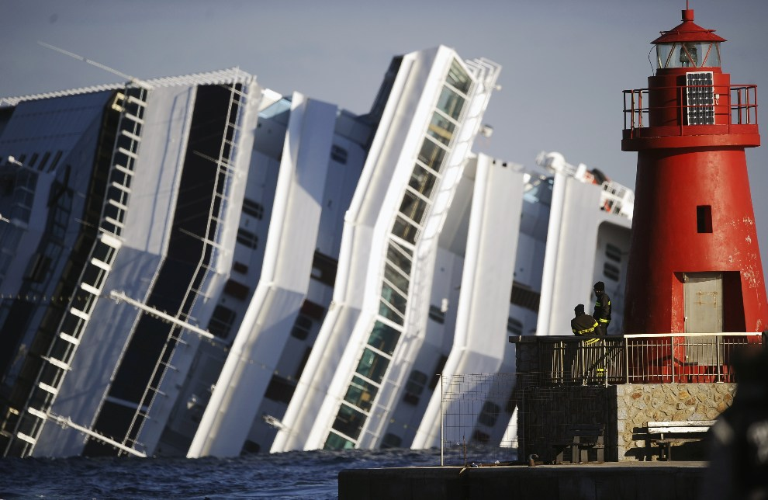
31st Italy, Isola del Giglio, Jan. 17, 2012: Firefighters look on an airplane zatopionemu Costa Concordia. AFP PHOTO / FILIPPO MONTEFORTE
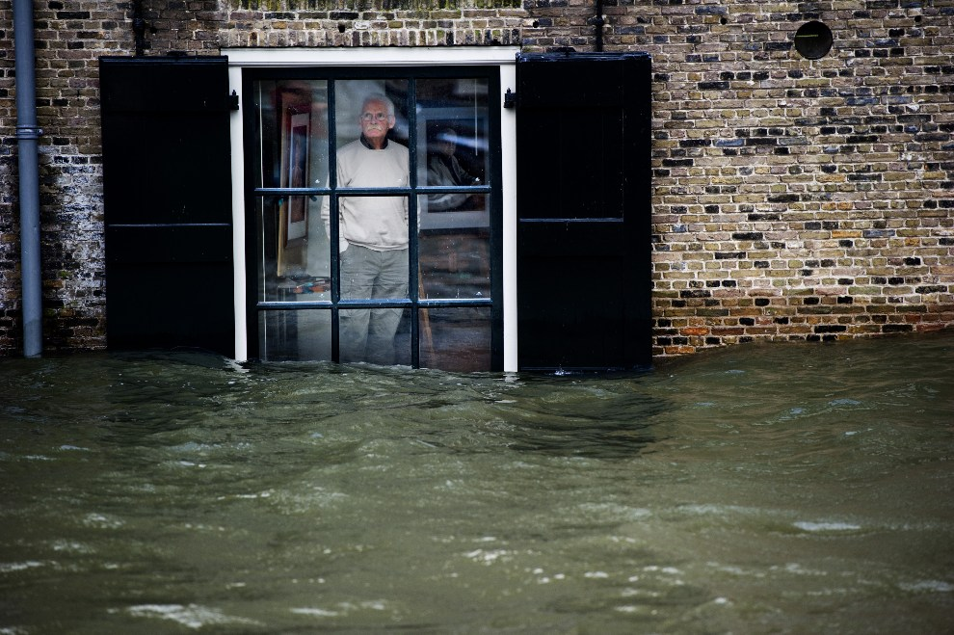
32nd NETHERLANDS, Dordrecht, Jan. 5, 2012: A man looks at the falling water during flooding on the coast of the Netherlands. AFP PHOTO / ANP / ROBIN UTRECHT
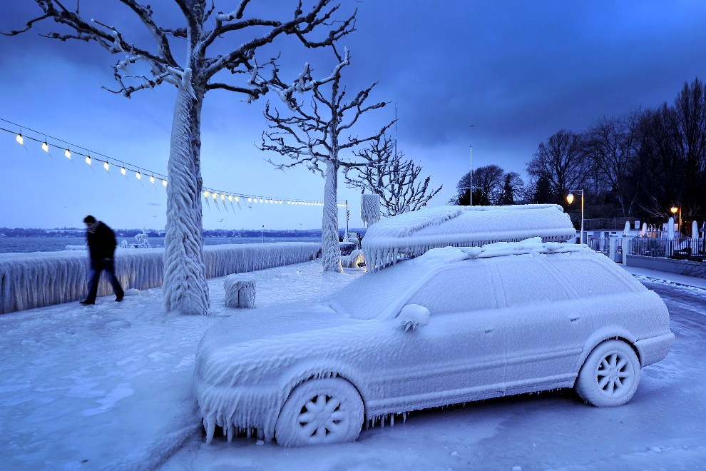
33rd SWITZERLAND, Versoix, February 5, 2012: Skuta ice promenade in Versoix. AFP PHOTO / FABRICE COFFRINI
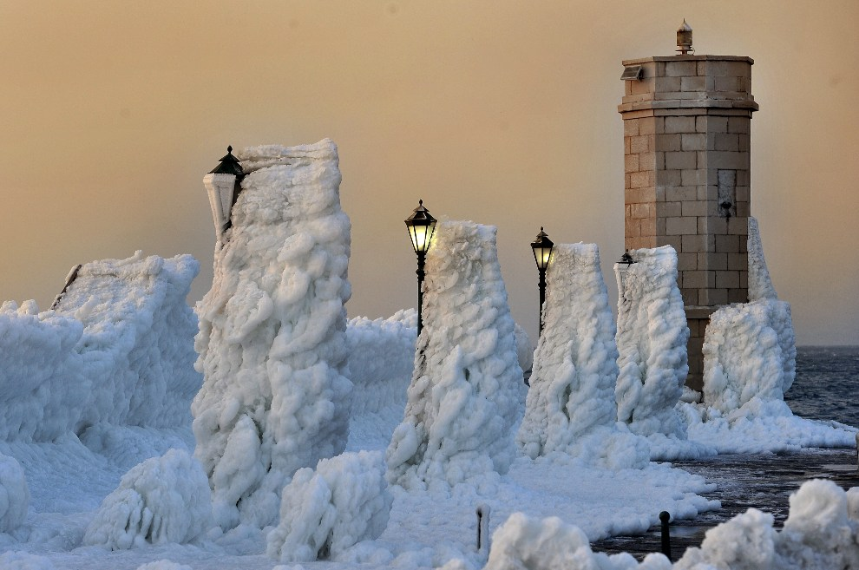
34th CROATIA, Senj, February 8, 2012: The entrance to the Croatian port of Senj. AFP PHOTO / Hrvoje POLAN
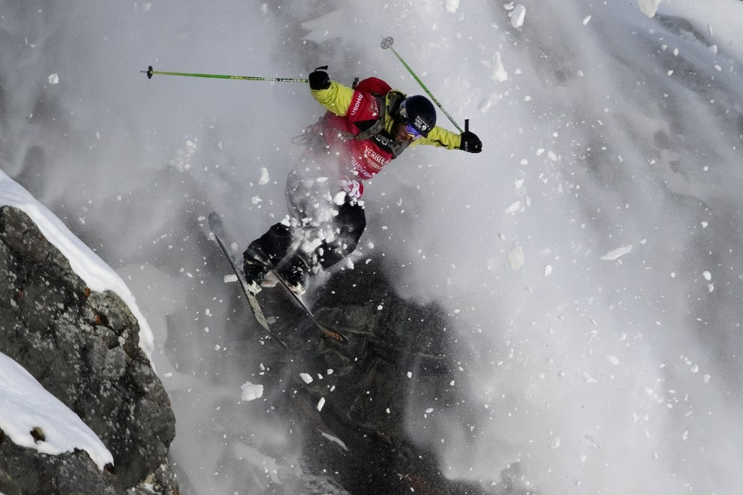
35th SWITZERLAND, Verbier, March 24, 2012: Argentine Nicolas Salencon during the contest Xtreme Freeride World Tour. AFP PHOTO / FABRICE COFFRINI
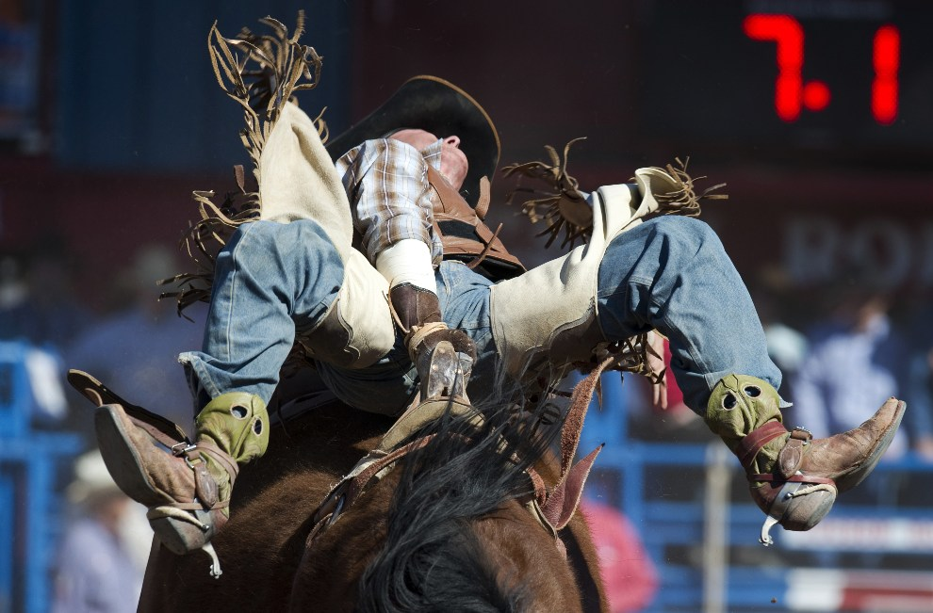
36th USA, Tucson, Feb. 26, 2012: Shon Gibson during a performance at the rodeo in Tucson. AFP PHOTO / DON Emmert
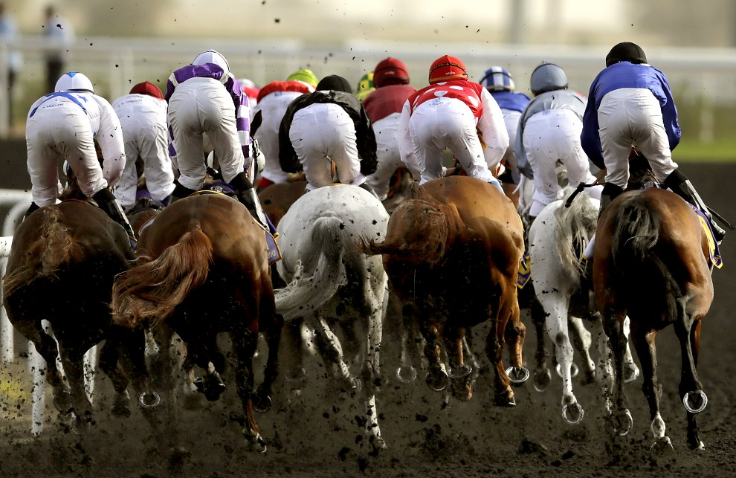
37th UNITED ARAB EMIRATES, Dubai, March 31, 2012: One of the races in Dubai Kahayla Classic. AFP PHOTO / MARWAN Naam
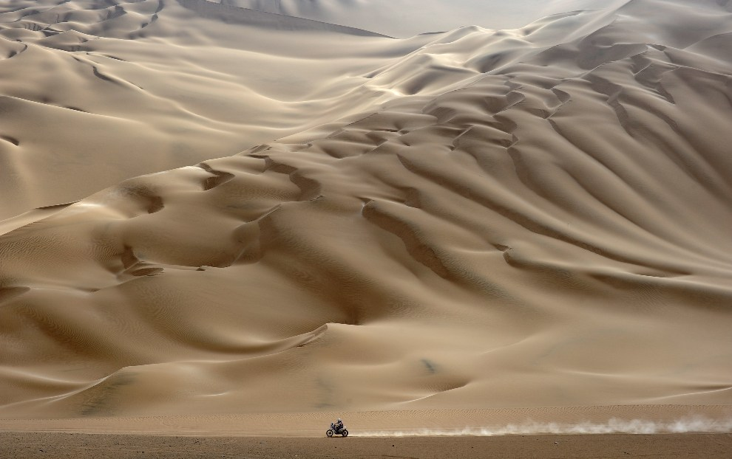
38th PERU, Arequipa, January 12, 2012: Motorcyclist from the eleventh section of the Dakar Rally. AFP PHOTO / PHILIPPE DESMAZES
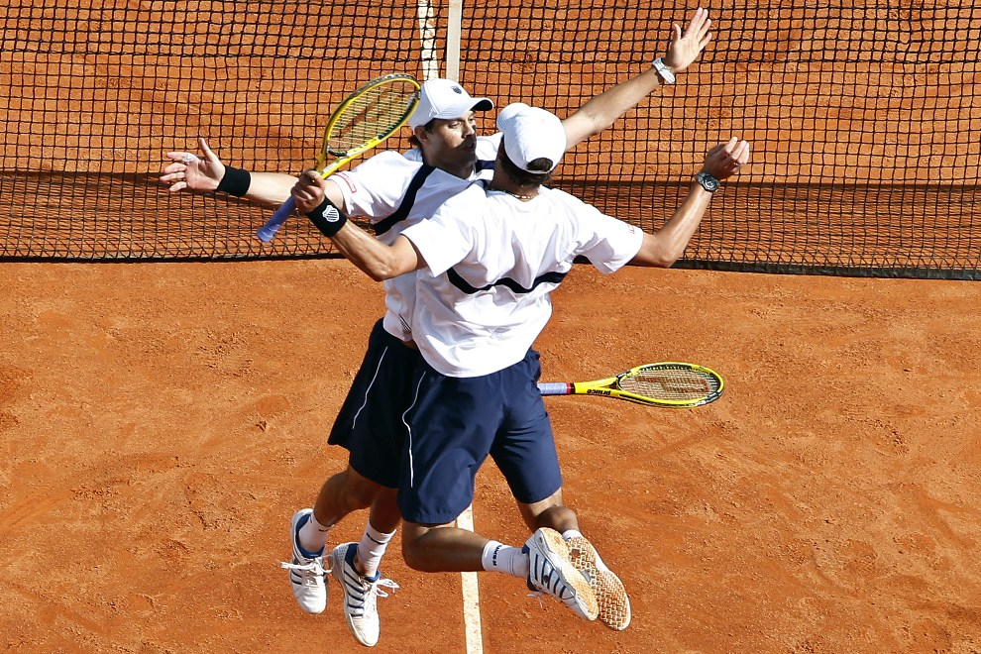
39th MONACO, Monte-Carlo, April 7, 2012: Mike Bryan (left) and Bob Bryan (right) celebrate their victory in a Davis Cup match. AFP PHOTO / SEBASTIEN Nogier
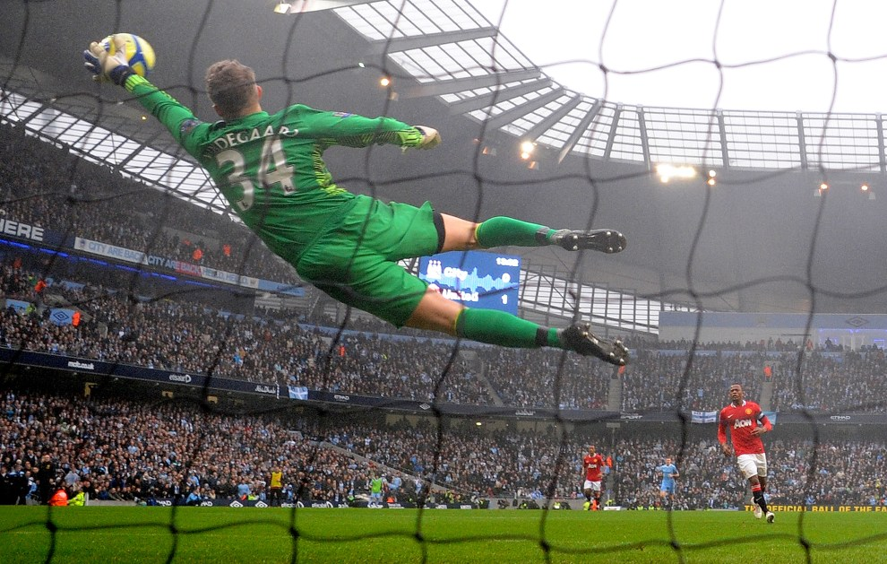
40th UNITED KINGDOM, Manchester, January 8, 2012: Anders Lindegaard makes a save player team Manchester City. AFP PHOTO / ANDREW YATES
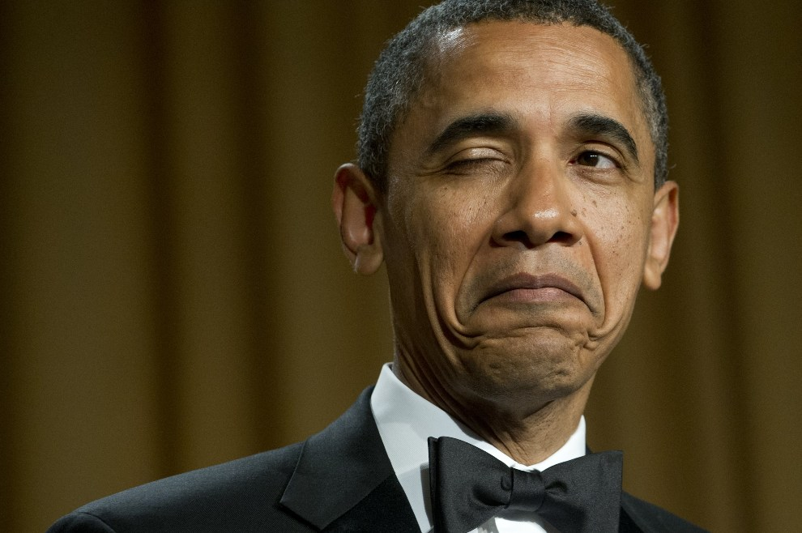
41st USA, Washington DC, April 28, 2012: Barack Obama "winks" telling a joke about his place of birth, at a din

