-----
Và đây, Tổng kết tin tức đó đây cùng hình ảnh trong năm 2012 (Phần II)

Moi xem tin tuc cung hinh
anh do day tong ket nam 2012
Phan II .
Than ai .
Thuan Nguyen .

2012 summary (Part II)
As you probably guessed, the second part of a summary of the year 2012 (the months of May-August) is full of sports photographs. In addition to the annual Tour de France, in the past year we have witnessed two major events: the Olympic Games in London and the European Championship in football organized by Ukraine and Poland. Despite the fact that our players are not particularly distinguished, but we had a few moments that are worth to recall again. In addition to sports, in today's package of photos, you will find photographs of the civil war-torn Syria and parts of Asia, which struck the flood.
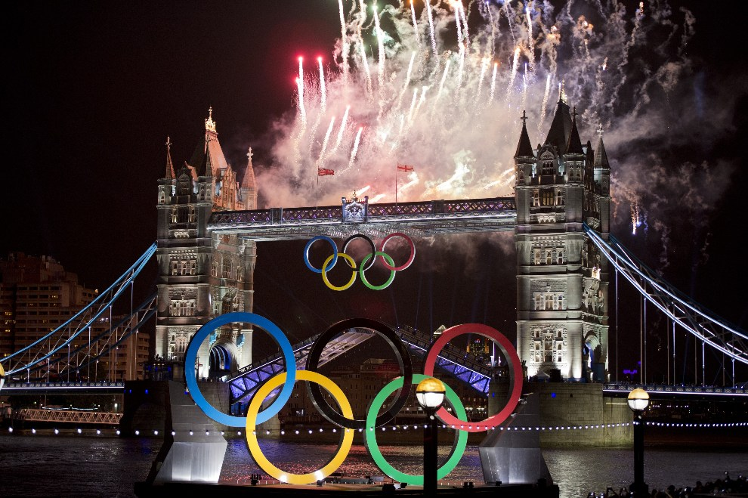
First UNITED KINGDOM, London, 27 July 2012: Fireworks over Tower Bridge during the opening ceremony of the Olympics. AFP PHOTO / JOHANNES EISELE
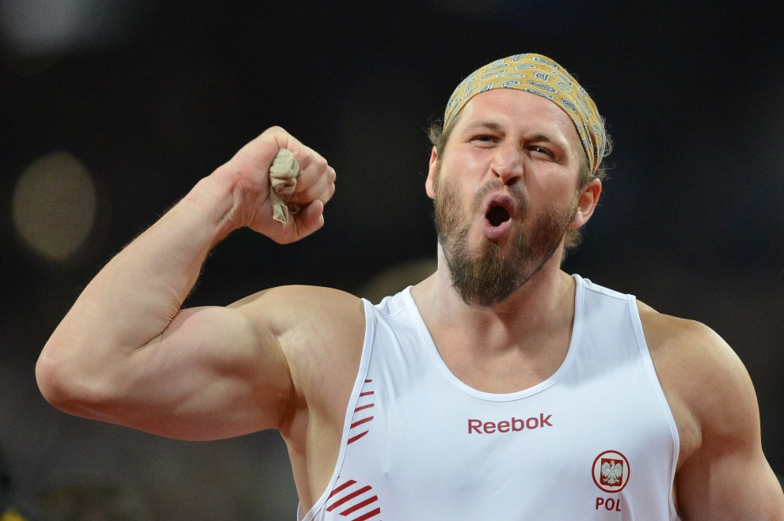
Second UNITED KINGDOM, London, 3 August 2012: Tomasz Majewski obronionego pleased with the championship in the shot put. AFP PHOTO / JOHANNES EISELE
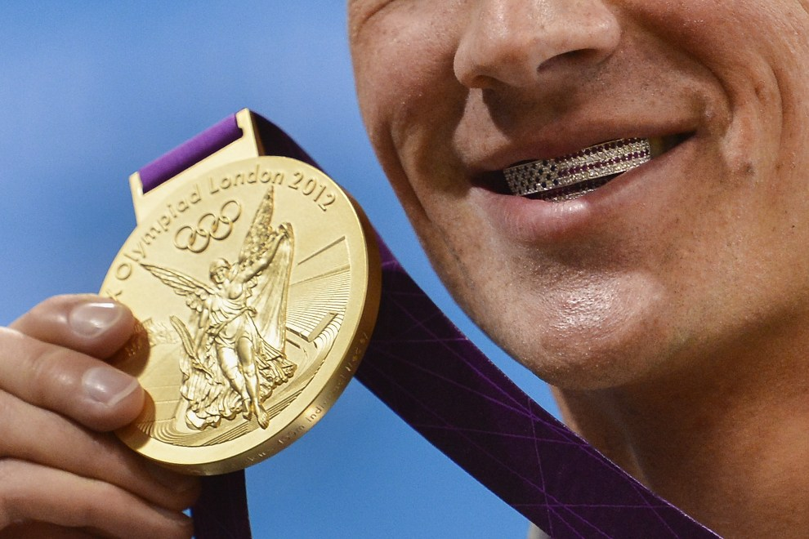
3rd UNITED KINGDOM, London, 28 July 2012: American Ryan Lochte poses for a photo after winning the gold medal. AFP PHOTO / FABRICE COFFRINI
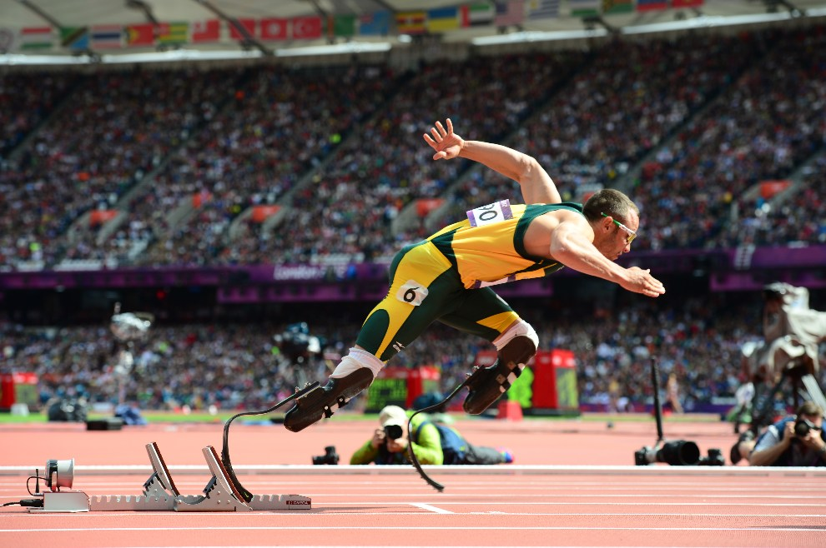
4th UNITED KINGDOM, London, August 4, 2012: Oscar Pistorius (South Africa) comes out of the blocks to run over a distance of 400 m AFP PHOTO / OLIVIER MORIN
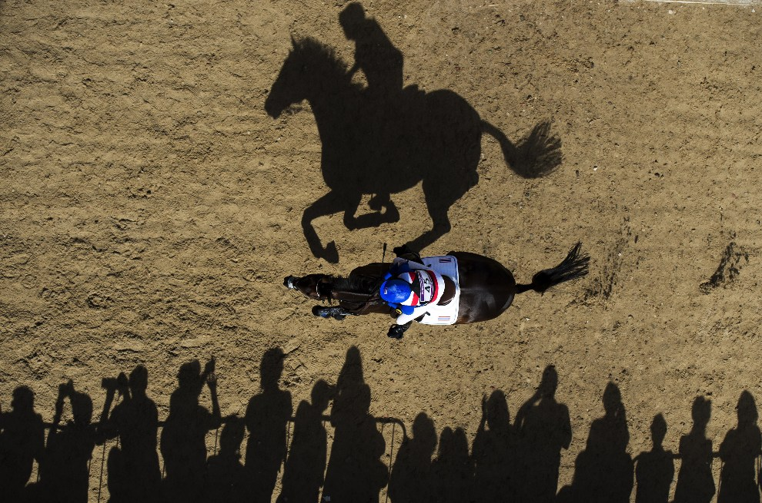
5th UNITED KINGDOM, London, July 30, 2012: Nina Ligon Lamsan (Thailand) on a horse Butts Leon. AFP PHOTO / ADRIAN DENNIS
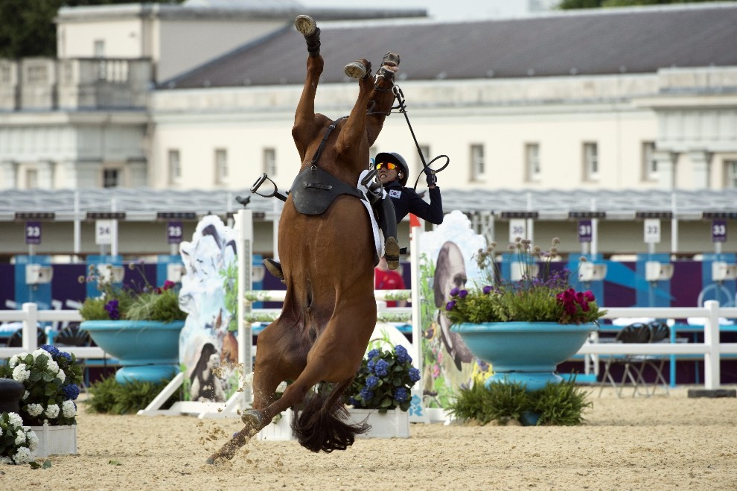
6th UNITED KINGDOM, London, 11 August 2012: Hwang Woojin loses control of the mount during a competition in jumping. AFP PHOTO / John MacDougall
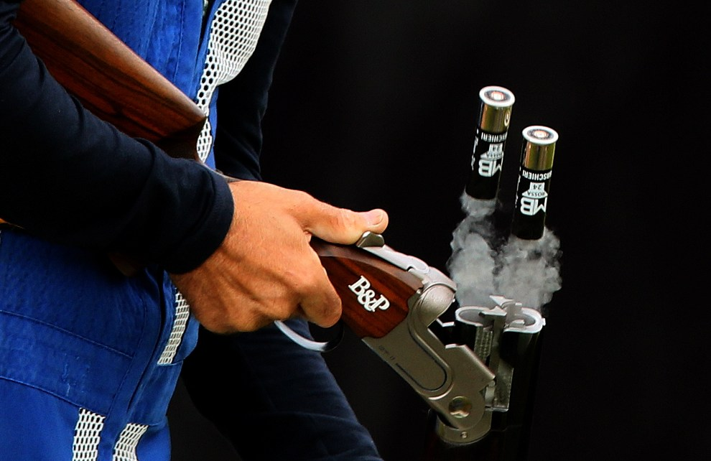
7th UNITED KINGDOM, London, 31 July 2012: Scale pop-up of the weapons belonging to Ennio Falco (Italy). AFP PHOTO / MARWAN Naam
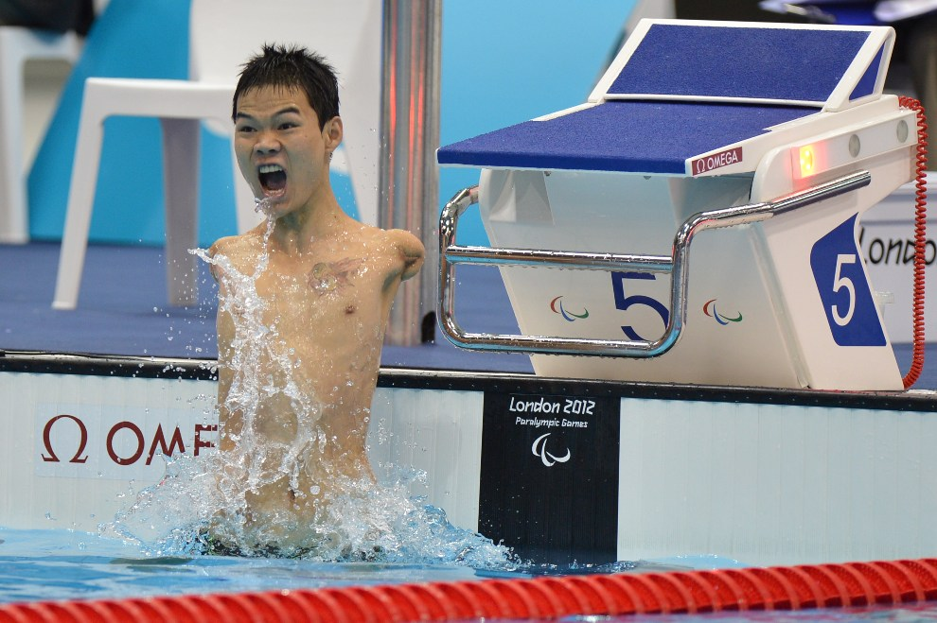
8th UNITED KINGDOM, London, August 30, 2012: Chinese Zheng Tao has to break the world record for a distance of 100m backstroke. AFP PHOTO / BEN STANSALL
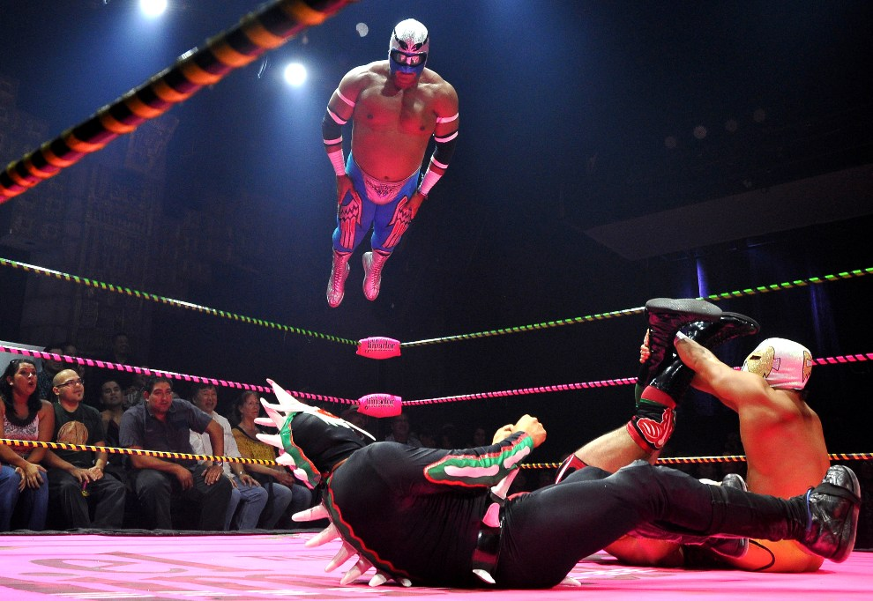
9th USA, Los Angeles, May 4, 2012: Performance at the gala luchadorów Lucha Va Voom's Cinco de Mayan. AFP PHOTO / JOE KLAMAR
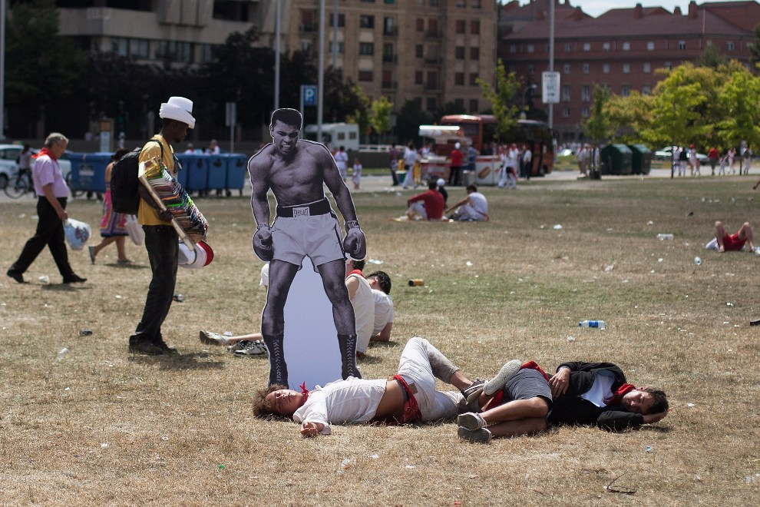
10th SPAIN, Pamplona, ​​July 8, 2012: Stand with the image of Muhammad Ali left the street next to the sleeping artist participants have fun. (Photo: Pablo Blazquez Dominguez / Getty Images)
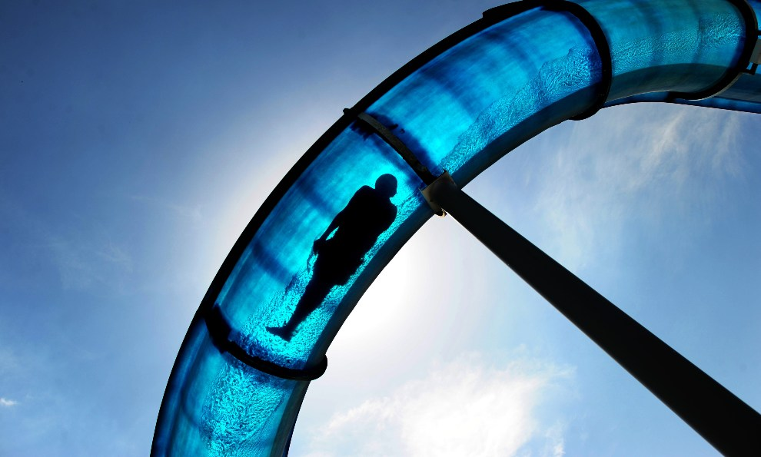
11th GERMANY, Hamelin, 22 May 2012: The boy came down on a hot day. AFP PHOTO / JULIAN STRATENSCHULTE GERMANY OUT
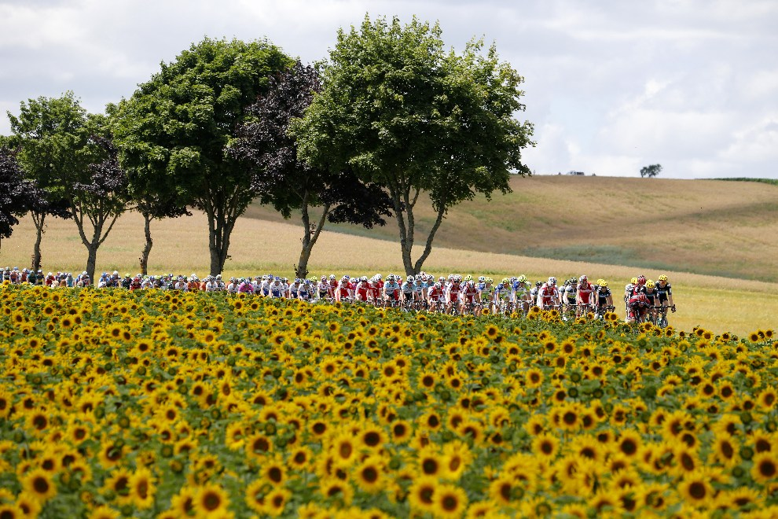
12th FRANCE, Plancher-les-Mines, July 7, 2012: PeletonTDF riding road between fields of sunflowers. AFP PHOTO / JOEL SAGET
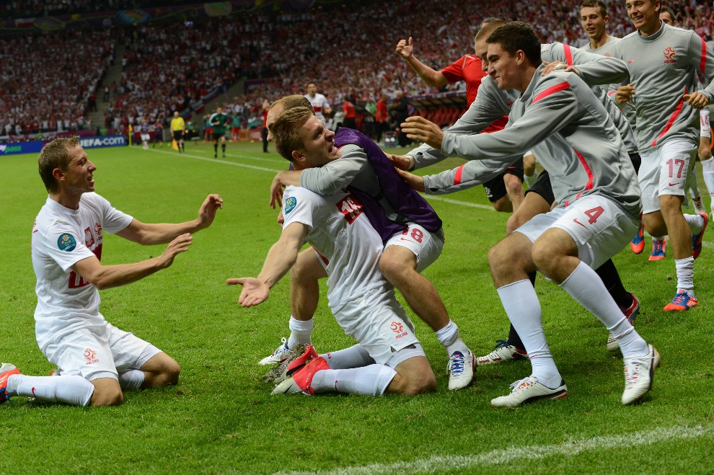
13th POLAND, Warsaw, 12 June 2012: Jakub Blaszczykowski celebrates his goal in the match gained with Russia. AFP PHOTO / FRED Skarzynski
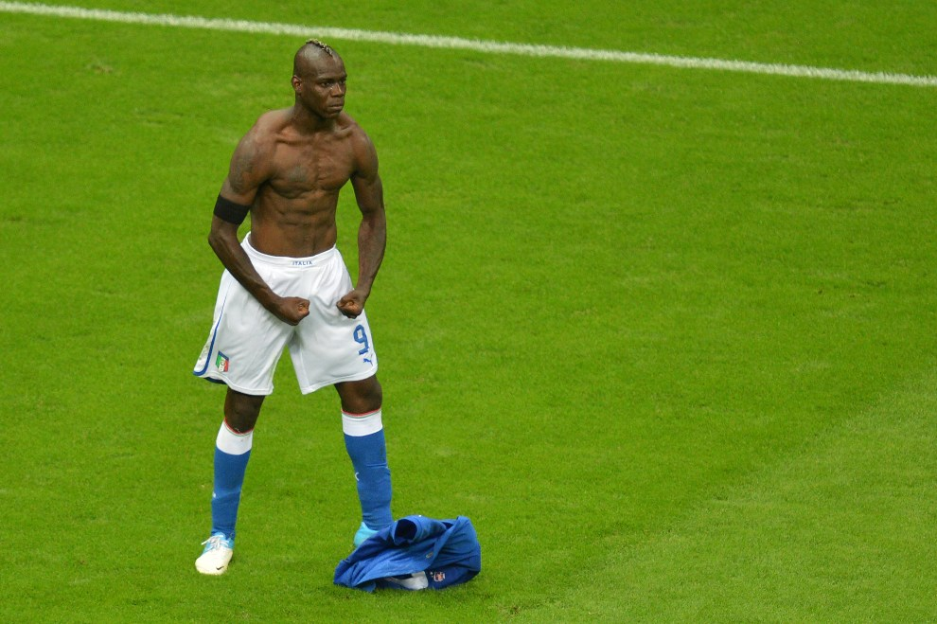
14th POLAND, Warsaw, June 28, 2012: Mario Balotelli pleased with the second goal in the match gained with Germany. AFP PHOTO / GABRIEL bouys
15th ITALY, Rome, July 4, 2012: Angela Merkel welcomed by the Prime Minister of Italy before the meeting on the ongoing crisis in the Eurozone. AFP PHOTO / GABRIEL bouys
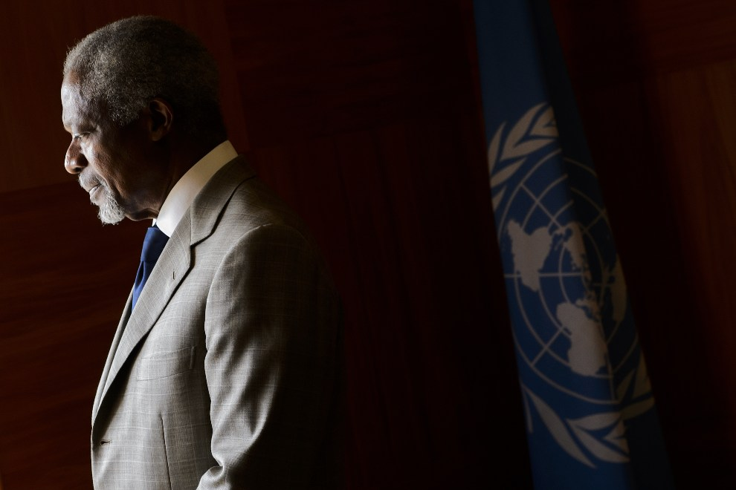
16th SWITZERLAND, Geneva, 20 July 2012: Kofi Annan dissatisfied with the course of talks to end the war in Syria. AFP PHOTO / FABRICE COFFRINI
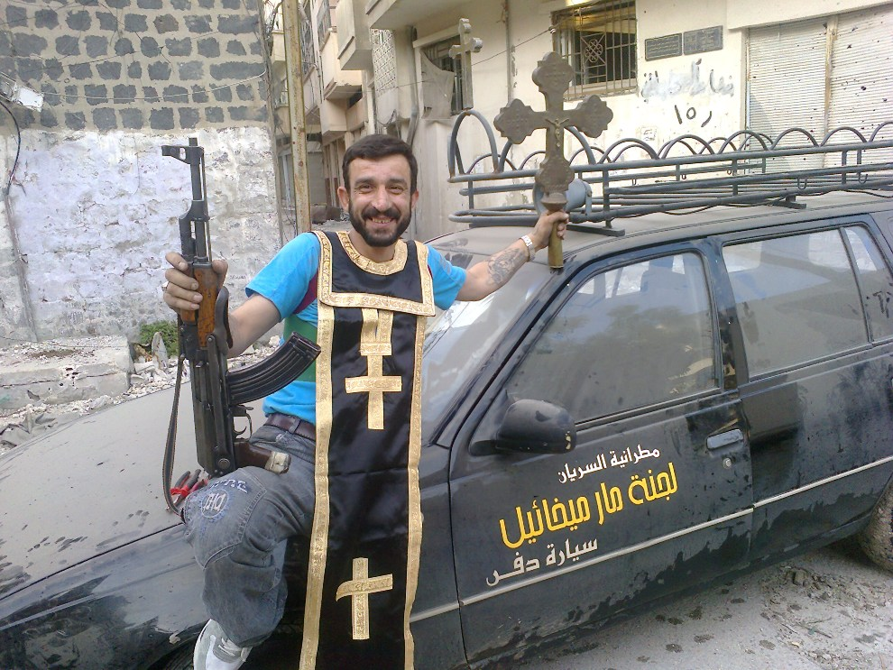
17th SYRIA, Homs, June 25, 2012: A man near the destroyed temple adherents of the Assyrian Church of the East. AFP PHOTO / Shaam News Network
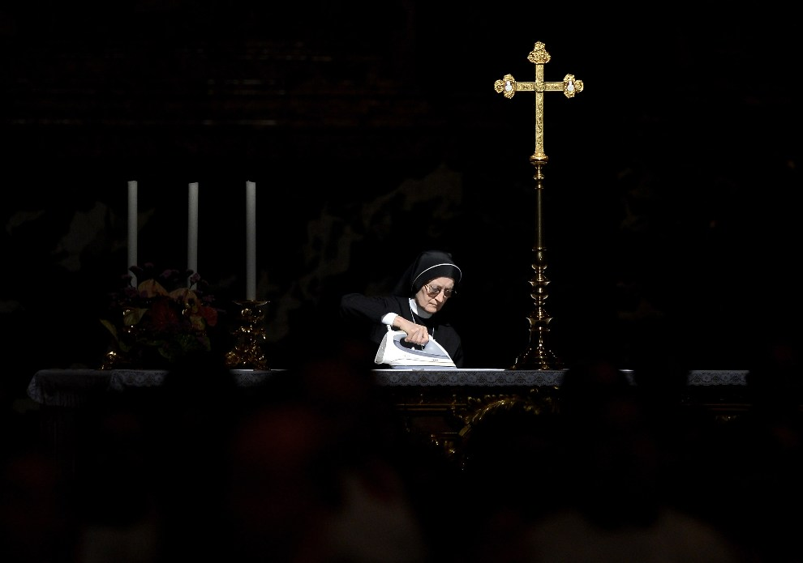
18th VATICAN CITY, May 27, 2012: Sister pressed tablecloth preparing the altar for the celebration of Mass by Pope Benedict XVI. AFP PHOTO / FILIPPO MONTEFORTE
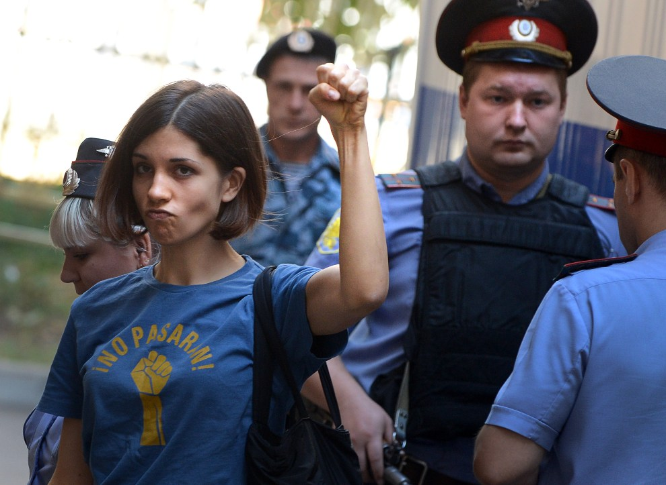
19th Russia, Moscow, 8 August 2012: Nadezhda Tolokonnikowa the band "Pussy Riot" entered the courtroom. AFP PHOTO / Natalia Kolesnikova
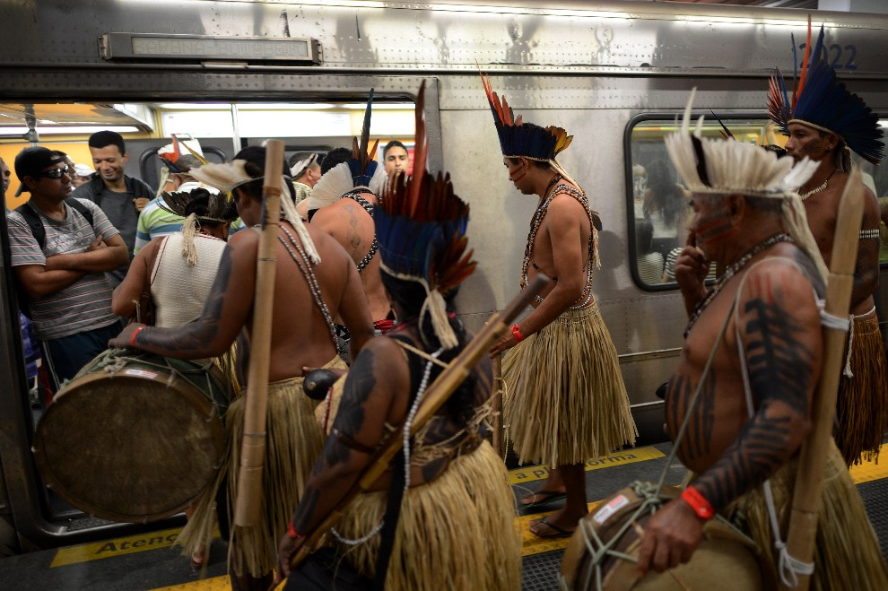
20th BRAZIL, Rio de Janeiro, June 16, 2012: Indigenous people in traditional costume on the subway. AFP PHOTO / Christophe Simon
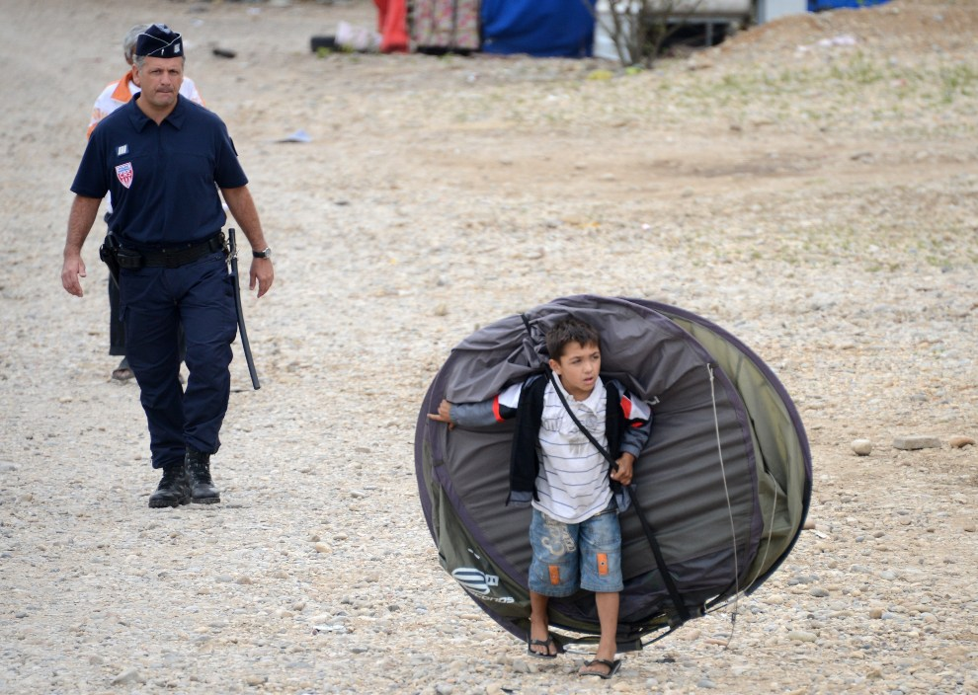
21st FRANCE, Saint-Priest, 28 August 2012: Roma tent carrying a child on her back, leaving the camp closed down by the police. AFP PHOTO / PHILIPPE DESMAZES
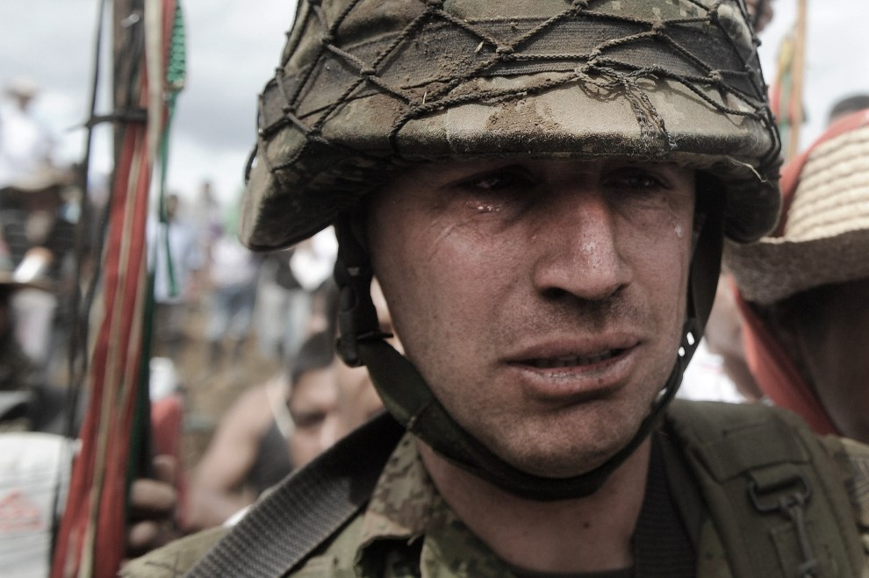
22nd COLOMBIA, Toribio, July 17, 2012: Sergeant Rodrigo Garcia crying leaving the station, from which the soldiers drove the local population. AFP PHOTO / Luis ROBAYO
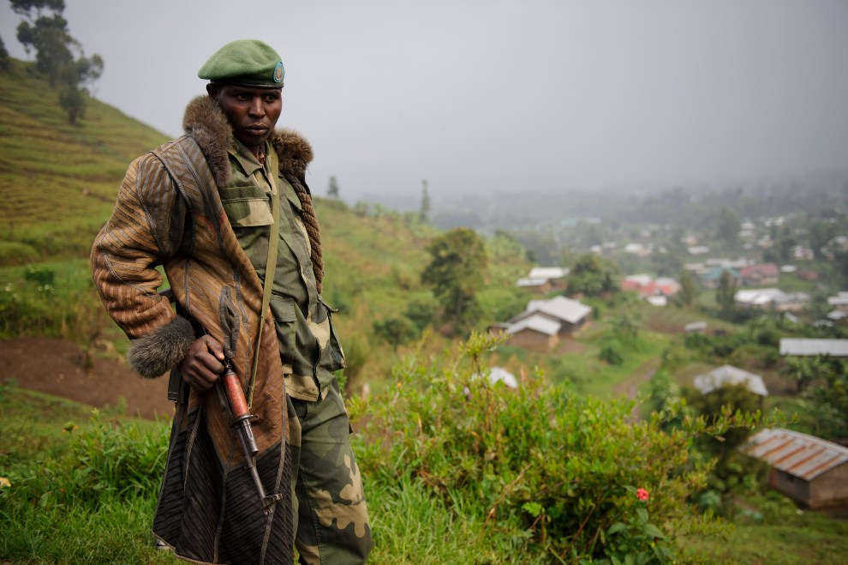
23rd DEMOCRATIC REPUBLIC OF CONGO, Bunagana, July 23, 2012: Rebel groups from observing M23 area. AFP PHOTO / PHIL MOORE
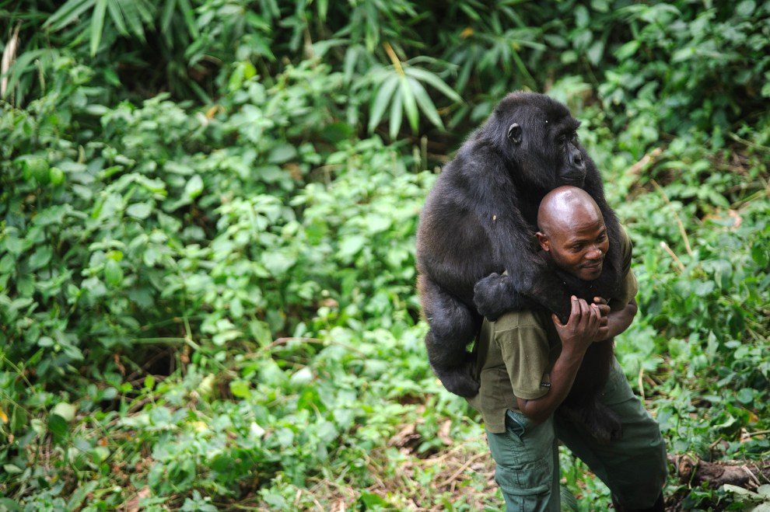
24th DEMOCRATIC REPUBLIC OF CONGO, Rumangabo, July 17, 2012: Patrick Karabaranga, the guardian of the Virunga park, carries an orphaned gorilla.AFP PHOTO / PHIL MOORE
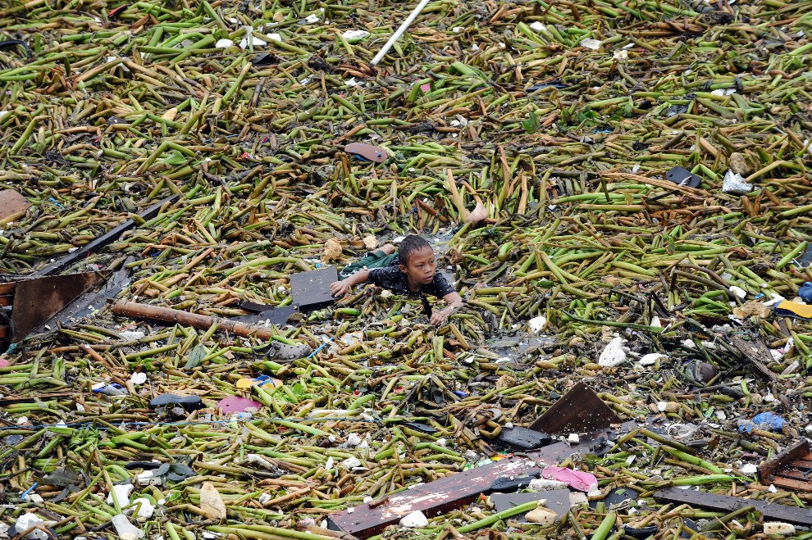
25th PHILIPPINES, Manila, July 30, 2012: Boy wyławiający items carried by the overflowing water. AFP PHOTO / TED ALJIBE
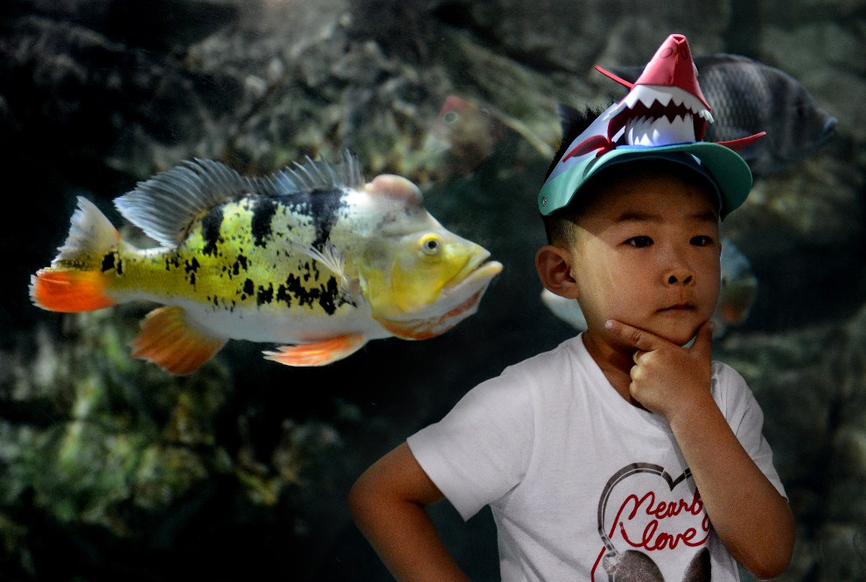
26th CHINA, Beijing, May 30, 2012: A boy posing for a photo during a visit to the city aquarium. AFP PHOTO / Mark RALSTON
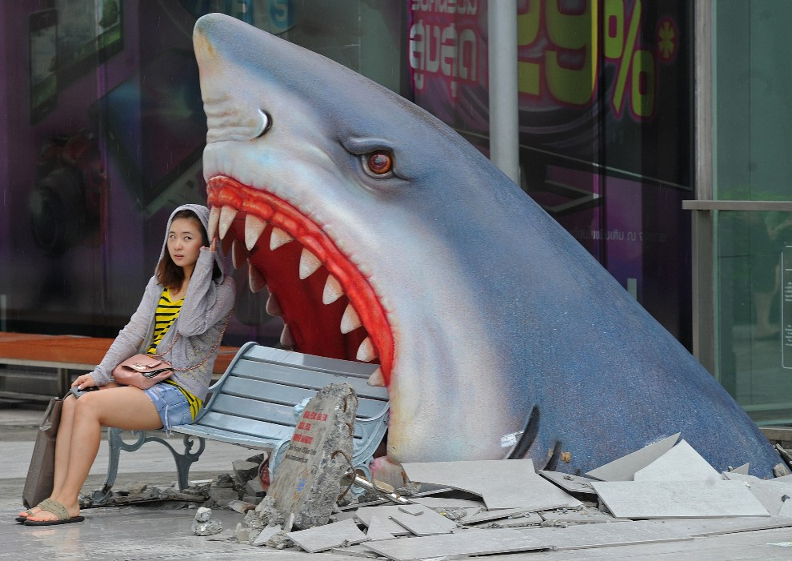
27th THAILAND, Bangkok, July 9, 2012: A tourist rests next to the plant in one of the malls. AFP PHOTO / Pornchai KITTIWONGSAKUL
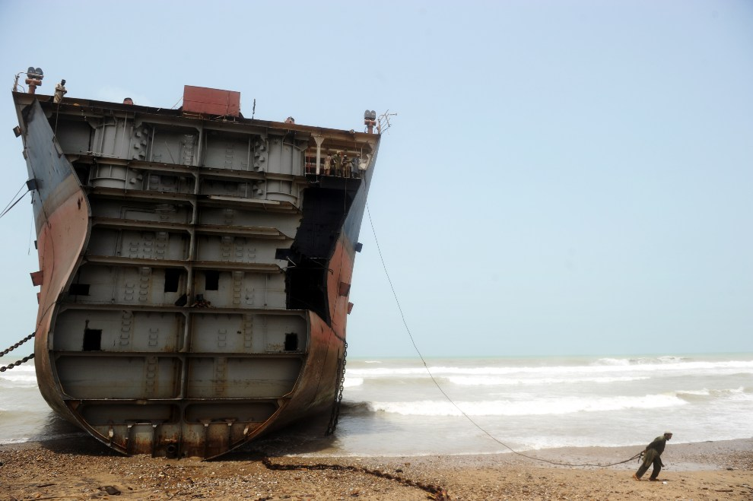
28th PAKISTAN, Gedda, July 10, 2012: A man tightens the rope he wants to break away from the metal part of the ship scrapped. AFP PHOTO / Roberto Schmidt
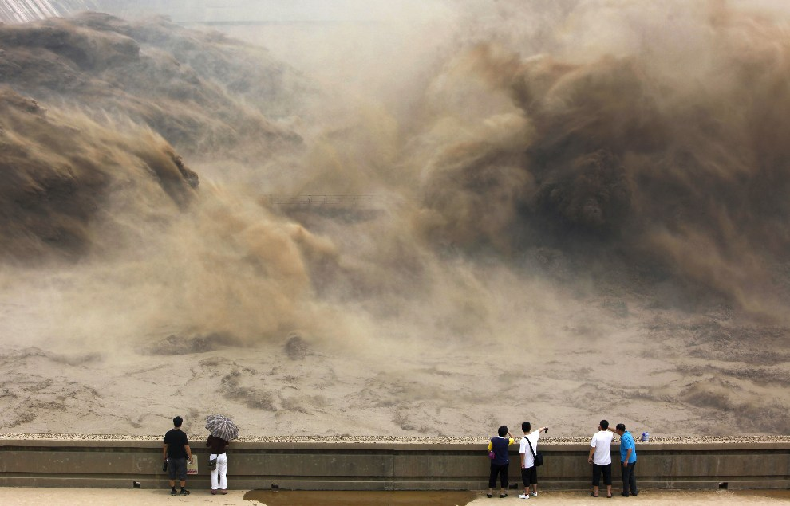
29th CHINA, Jiyuan, July 6, 2012: dump water on the Xiaolangdi dam (Yellow River). AFP PHOTO
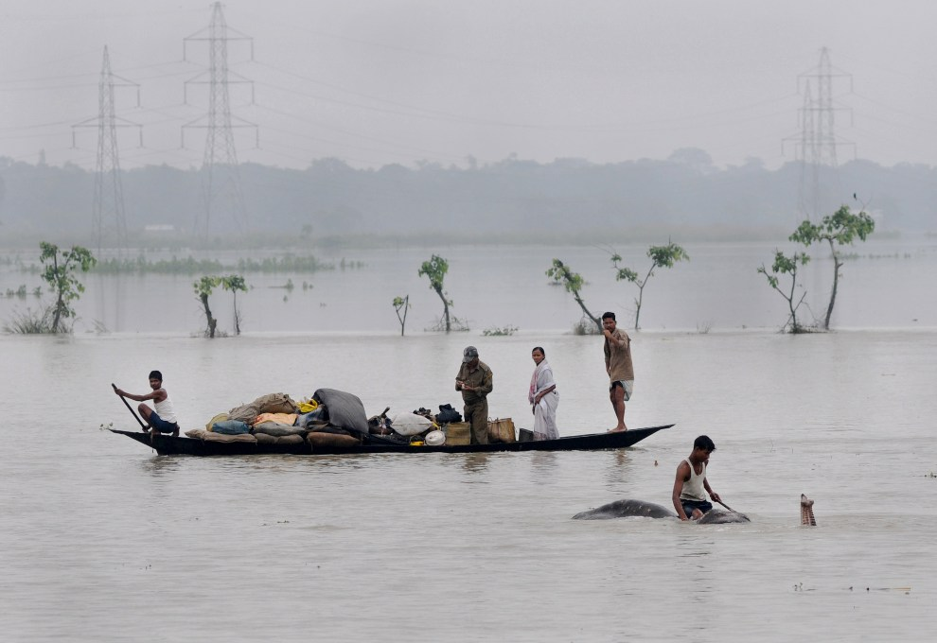
30th INDIA, Pobitora, June 28, 2012: People with their belongings on a boat and a man on an elephant does not move to the flooded areas. AFP PHOTO / Biju BORO
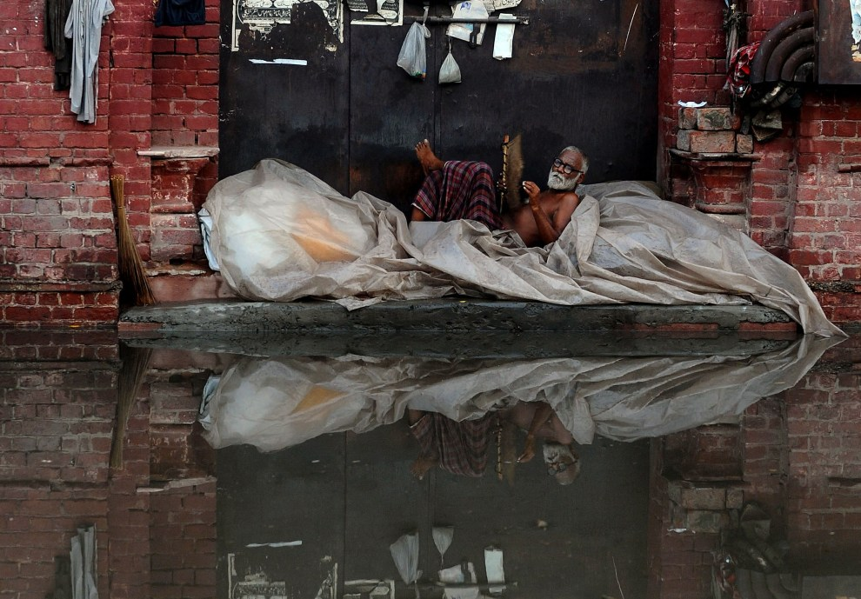
31st PAKISTAN, Lahore, July 22, 2012: Homeless protected against water flooding the streets of Lahore. AFP PHOTO / Arif ALI
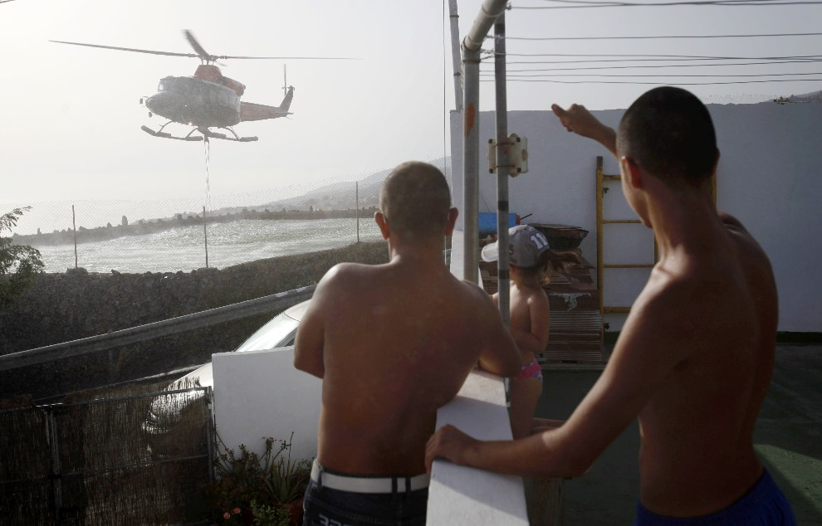
32nd SPAIN, Tenerife, July 19, 2012: Helicopter takes water from the swimming pool at one of the houses on the island of Tenerife. AFP PHOTO / Desiree Martin
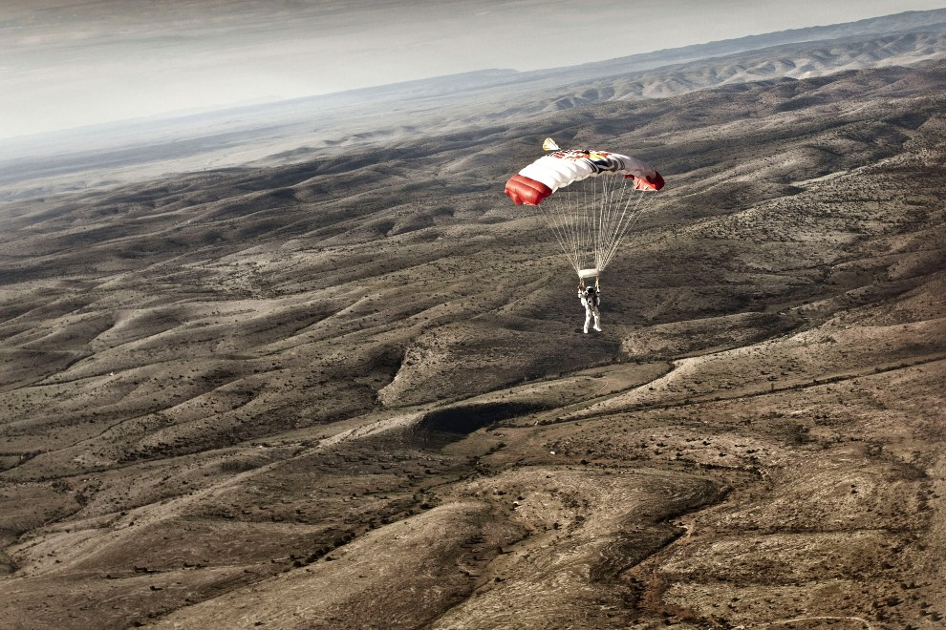
33rd USA, Atlanta, July 25, 2012: Felix Baumgartner comes to a successful landing after a training jump. AFP PHOTO / RED BULL
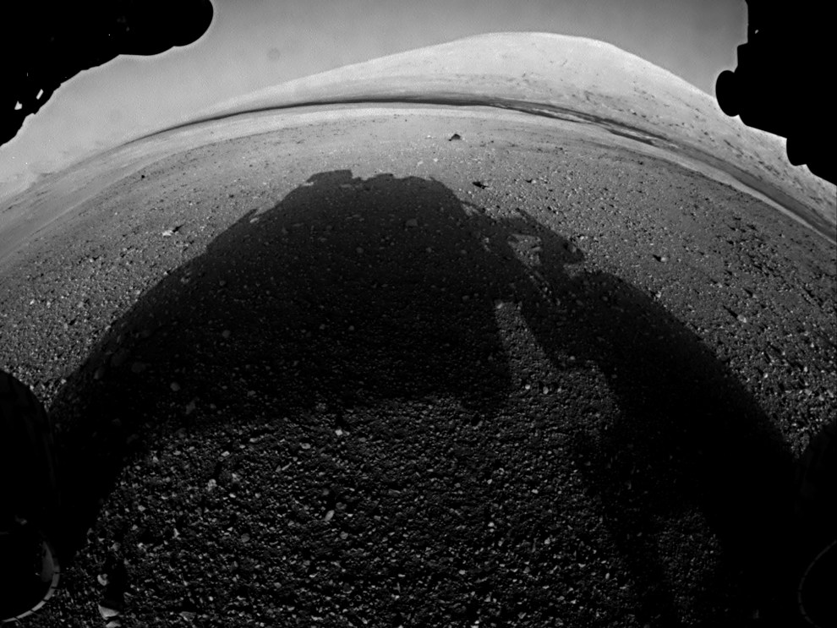
34th MARS, 7 August 2012: Photo taken on the surface of Mars Curiosity vehicle. AFP PHOTO / Handout / NASA / JPL-Caltech / Malin Space Science Systems
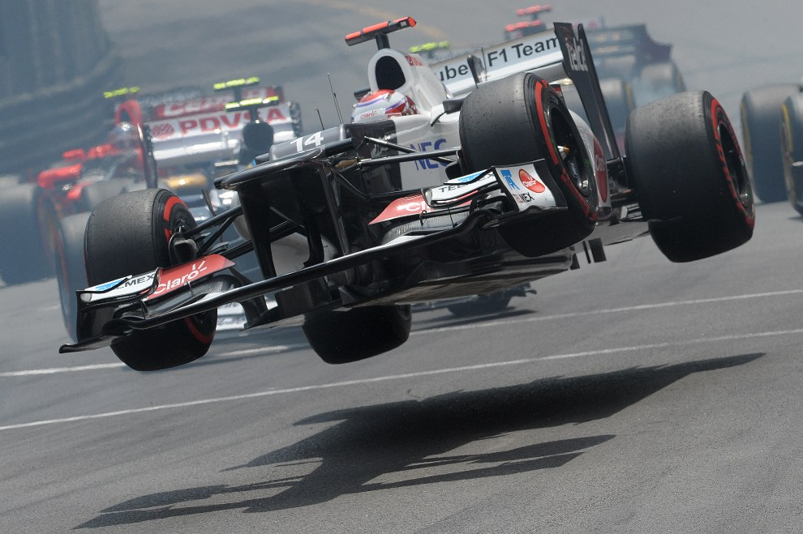
35th MONACO, May 27, 2012: Kamui Kobayashi lost control of the car while GB Monaco. AFP PHOTO / TOM Gandolfini
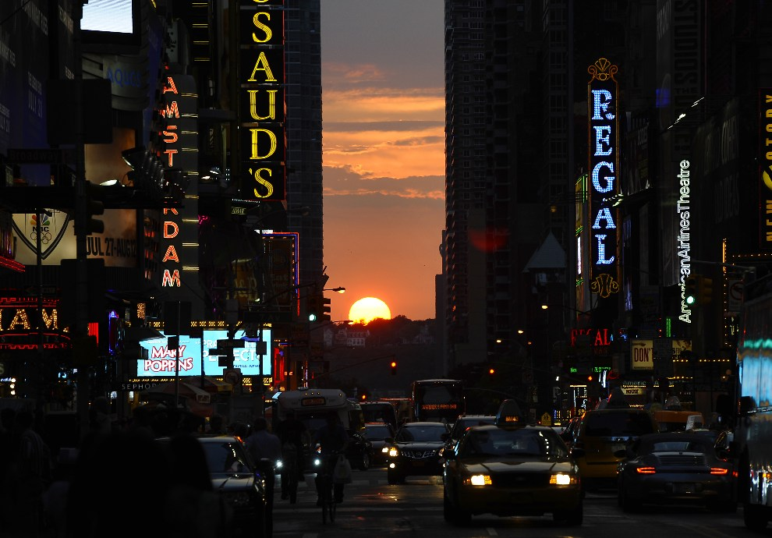
36th USA, New York, July 11, 2012: Sunset called Manhattanhenge, observed twice a year, when the sun perfectly equal to the direction of the western and eastern streets of Manhattan. AFP PHOTO / TIMOTHY A. Clary
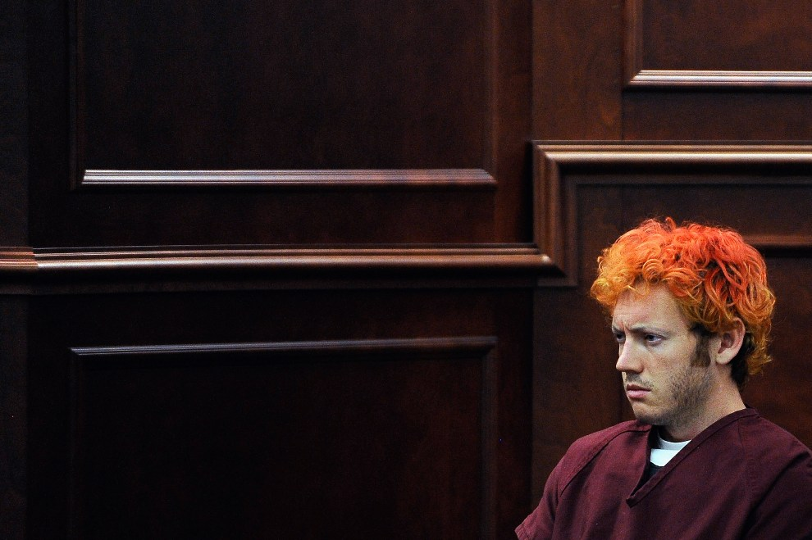
37th USA, Centennial, July 23, 2012: James Holmes at the start of the process in the shootout during which 12 people were killed and 58 were injured.(Photo: RJ Sangosti-Pool/Getty Images)

