Nem Nướng̣ - Vietnamese Grilled Pork Patties
Công thức nem nướng này từ website The Spice of Life, website này có khá nhiều món với phân lượng và cách làm rất xác đáng, bếp nhà ta xin phép được mang về chia sẻ với cả nhà NTH

*
Ingredients
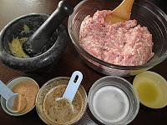
2 lbs ground pork
2 heads garlic (củ tỏi), finely chopped or minced into fine paste (use mortar and pestle or food processor)
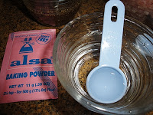2 teaspoons of Alsa baking powder or any single-acting baking powder brands
4 tablespoons water
1/2 teaspoon salt
2 tablespoons good fish sauce (prefer 3 crabs brand)
4 tablespoons sugar
1-2 teaspoons ground pepper
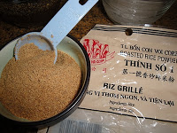2 tablespoons roasted rice powder (thính)
1 tablespoon oil
1 drop of red color, optional
20 wooden skewers (soaked in water for 20 minutes), optional

Accompaniments
Rice paper wrappers
Fried rolls, optional
Lettuce
Cucumbers, thinly sliced
Pickled carrots and daikon , optional or
Granny Smith apples, thinly sliced, dipped in slightly salty water for few seconds then removed it to keep apple from turning brown
perilla (tía tô)
Mint (rau thơm)
Cilantro (ngò)
Fresh chives (hẹ)

Making Fried Roll
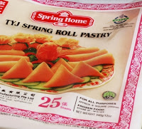
Use small size of Eggroll Wrappers

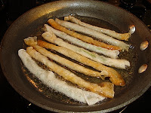
Cut egg roll wrappers into half. Roll it up but not too tightly. Use an egg wash to seal the wrapper. Heat the oil until hot, then reduce the heat to medium. Fry until golden brown, drain on a paper towel and set aside.

Preparing Meat
In a large bowl, combine the ground pork, garlic, salt, fish sauce, sugar and white pepper. Kneed the pork mixture until all the ingredients are well mixed.
In a small bowl, mix water, color if used and baking powder. Stir the mixture until it foams up. Pour baking powder mixture into the pork mixture. Knead the pork mixture until all the ingredients are well mixed. The baking powder adds firmer and bouncier texture. Color will enhance the color of pork when grilled. However, I didn't use it in my food since I just want it as natural as I can.
Add roasted rice powder to the mixture to enhance the aroma and taste. Mix it well.
Cover the meat mixture and let it rest in the refrigerator for at least 2 hours or overnight so that flavors can develop and the meat gets firmer which makes it easier to form patties, skewers or balls.
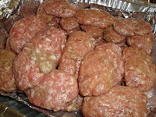Rub a small amount of oil into the palm of your hands so that the meat does not stick to it. Now you can form any shape you would like.

Turn on your grill or charcoal and grill it at medium high heat until it turns golden brown. If broiling, leave the oven door slightly open while broiling. Since the broiler uses such high temperatures, it can easily burn and ruin a dish if not properly monitored. Leaving the oven door partially cracked gives you a view of foods as they brown and cook in the broiler and helps ensure that you can easily remove a dish before it burns.
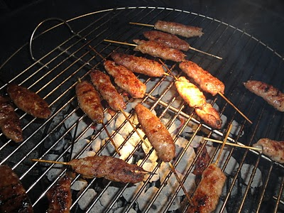
*
Nem Nướng Presentation
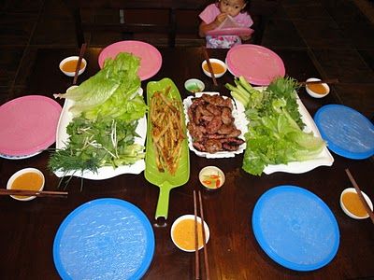

Dip a rice paper in luke warm water. Place the rest of the accompaniments and patties on wet rice paper then roll it up. Dip it in your favorite sauce and enjoy.
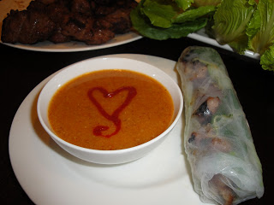
Nem Nướng can also be served in a bowl with bún (vermicelli rice noodle), roasted peanut, fresh vegetables, herbs, bean sprouts, and pickled carrot. However, I prefer eating Bún Nem Nướng with dipping fish sauce.
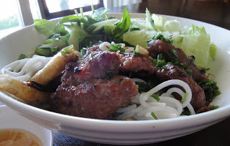
* * *
*
*Raw Nem Nướng can be frozen and used later. Whenever you crave for it, just defrost frozen nem nuong the night before in the fridge.
*Granny Smith Apples are crisp, juicy, and tart. It's great for salads.

